

**AGREEMENT FOR THE PROVISION OF FUNDING**

**RELATING TO**

**[ ]**

**between**

**The Greater London Authority**

**-and-**

**[ ]**

***Note: Where the proposed Recipient is also an ESF Sponsor you must ensure that they execute (signs/seals as a deed) both: (i) this Agreement; and (ii) the related ESF Sponsor Agreement, before the GLA executes either.***

**Summary sheet for publication**

In compliance with the Local Government Transparency Code 2015

The Greater London Authority must publish details of all grants to voluntary, community and social enterprise organisations. **By signing the grant agreement above (and any variation thereof), organisations are also accepting the publication of the information** set out below (by GLA officers) and confirming its accuracy:

|  |  |  |
| --- | --- | --- |
| **Overarching grants programme:** | Name of the grant funding programme/pot | |
| **Description/Purpose of the grant:** | *Brief explanation* | |
| **The grant was for a total of:**  **The varied grant is now for a total of:** | *In pounds*  *In pounds* | |
| **The grant was awarded on:**  **The grant was varied on:** | YYYY/MM/DD  YYYY/MM/DD | |
| **The original grant covered the**  **following time period:**  **The varied grant now covers the**  **following time period:** | From YYYY/MM/DD to YYYY/MM/DD  From YYYY/MM/DD to YYYY/MM/DD | |
| **It is awarded to:** | Name of Recipient Organisation | |
| **The recipient is:** | A *voluntary and community sector organisation:*  *A social enterprise:*  *Other:*  *If “Other” please provide more detail* |  |
| **Company or charity registration number:** | *Company number: ____________*  *Charity number:____________* | |
| **It was awarded by:** | *Relevant GLA team and directorate* | |
| **The award of this grant was**  **formally approved by:**  **The variation of this grant was**  **formally approved by:** | *MD/DD/ADD/DAR*  *MD/DD/ADD/DAR* | |

*IN ORDER FOR THE GLA TO COMPLY WITH THE 2014 LOCAL GOVERNMENT TRANSPARENCY CODE,* ***THE GLA OFFICER WILL FORWARD THIS SHEET AND THE FUNDING LETTER TO THE GOVERNANCE TEAM*** *AS SOON AS IT IS SIGNED AND AN UPDATED VERSION WITH A COPY OF ANY VARIATION AS SOON AS IT IS SIGNED .*

*(Azadur Rahman* [*azadur.rahman@london.gov.uk*](mailto:azadur.rahman@london.gov.uk) */ Post Point 11 / Tel extension: 4818)*

**THIS AGREEMENT** is made this day of 2018

**BETWEEN:**

(1) **THE GREATER LONDON AUTHORITY** whose principal offices are at City Hall, The Queen’s Walk, London, SE1 2AA (“the Authority”); and

1. **[ ]** (Company/Charity registration no: [ ] ) [of/whose principal office is at] [ ] (“the Recipient”)

**IT IS HEREBY AGREED THAT**:

**1. Background**

* 1. The Recipient requested funding from the Authority and provided to the Authority a proposal for the use of such funding. A copy of the Recipient’s proposal is on file at the Greater London Authority.
  2. Under its powers under Sections 30 and 34 of the Greater London Authority Act 1999 to do anything it considers will facilitate or which is conducive or incidental to the promotion of economic, social development and wealth creation in Greater London, the Authority wishes to assist the Recipient in its programme/project [*add project title and brief description*] by the provision of the GLA Funding to the Recipient.
  3. The Recipient’s total costs of fulfilling the Project Objectives are [*words*] pounds sterling (£[*numbers*], the Recipient has committed itself to meeting the Project Objectives and contributing [*words*] pounds sterling (£[*numbers])* to the Project (“the Recipient’s Contribution”)] and use all reasonable endeavours to secure Additional Funding for use in meeting the Project Objectives.
  4. This Agreement sets out the terms and conditions upon which the Authority will make the funding available to the Recipient.
  5. The provision of the GLA Funding amounts to a conditional gift and is therefore not subject to VAT. If, at any time, it is held by the UK government to be subject to VAT, then the Recipient agrees and acknowledges that the GLA Funding shall have included any and all applicable VAT.
  6. [The Recipient will be required, on or about the date of this Agreement, to enter into Security over certain of its property in favour of the Authority to secure the obligations of the Recipient to the Authority under this Agreement/The Recipient will be required, within such time period as shall be communicated by the Authority to the Recipient in writing, to enter into Security over certain of its property in favour of the Authority to secure the obligations of the Recipient to the Authority under this Agreement*]. ***(*If applicable please select appropriate option and delete other as applicable. If not applicable delete all and mark clause “Not Used” )***
  7. Where the Recipient is an ESdrF Sponsor it shall also, as a condition of this Agreement cooperate fully with the Authority and provide the Authority with such assistance as the Authority requires in relation to any ESF Project which shall include (without limitation) complying fully with the ESF Sponsor Agreement.
  8. In this Agreement capitalised terms shall have the meaning prescribed to them in Clause 21.

**2. The Project Objectives**

2.1 The Recipient shall use the GLA Funding only to meet the ProjectObjectives in relation to the Project in accordance with this Agreement.

2.2 The Recipient hereby warrants that it has sufficient resources, including competent and qualified personnel, financial resources, premises and other resources as necessary, to meet the Project Objectives fully in accordance with this Agreement.

### 2.3 The Recipient shall:

### (a) promptly and efficiently deliver the Project Objectives and complete the Project fully in accordance with this Agreement; and

### (b) where the meeting of Project Objectives consists of the achievement of:

### Milestones, notify the Authority in writing immediately upon becoming aware that any Milestones are unlikely to be achieved fully in accordance with this Agreement: and

### Deliverables, notify the Authority in writing immediately upon becoming aware that any Deliverables are likely to exceed or are likely to be less than the relevant agreed number of Deliverables set out in the Annex to Schedule 1.

2.4 Where the Project involves any element of urban design, sustainability, streetscape design and or architecture, the Recipient shall submit full details of such proposed design and/or re-design work to the Authority for its consideration and will co-operate and engage fully with the Authority to agree design dialogue arrangements to be followed (in accordance with available guidance issued or published by the Authority from time to time) in the procurement, commissioning and undertaking of agreed design and/or re-design work. To the extent that the undertaking of any agreed design and/or re-design work necessitates in the opinion of the Authority, the amendment of this Agreement all such amendment shall not be valid unless made in accordance with Clause 11.

**2A. Designated Capital and Revenue Funding and Recipient’s Contribution**

2A.1 The Recipient's statutory chief finance officer or other officer validly authorised to act on his or her behalf has certified that of the GLA funding: (a) [words]pounds sterling (£[numbers]) will be used solely as a contribution to revenue expenditure; and (b) [words]pounds sterling (£[numbers]) will be used solely as a contribution to capital expenditure, incurred in relation to the Project Objectives such certification being made on the basis that the Recipient’s determination of capital expenditure accords fully with all laws and best practice, is estimated to deliver benefits that will accrue over a period of 15 years on average and on the basis that it will be recorded in the Recipient’s accounts in this manner. A copy of the certification is attached at Schedule 7 to this Agreement.

2A.2 The Recipient shall ensure that it has secured the Recipient’s Contribution on or before [31 March 2018]. For the avoidance of doubt where the Recipient’s Contribution comprises any sum(s) to provided by a third party such component sum(s) shall not be deemed secured unless a legally binding obligation to provide such sums is in place between the Recipient and such third party funder(s) evidence of which must be provided to the Authority on or before [***date***].

**3. Duration of Agreement and Funding breakdown**

This Agreement shall commence on the date at the head of this Agreement and, subject to the provisions for early termination set out in this Agreement, shall continue in force until [***date***].

**4. Payment, Performance Monitoring and Repayment Arrangements**

4.1 Subject to the Recipient complying with all of the terms of this Agreement, the Authority shall pay to the Recipient a sum not exceeding the GLA Funding, such payments to be made in accordance with the Funding Schedule and this Clause 4. For the avoidance of doubt the GLA Funding is capital funding and the Recipient shall not be permitted to make claims for GLA Funding in respect of revenue expenditure.

4.2 Where Project Objectives are to be met on a

1. Milestone basis the provisions of Part A of the Funding Schedule shall apply to and govern the Recipient’s making of claims for and the Authority’s making of payments of GLA Funding; and
2. Project Output basis, the provisions of Part B of the Funding Schedule shall apply to and govern the Recipient’s making of claims for and the Authority’s making of payments of GLA Funding.

4.3 The Recipient shall use all reasonable endeavours to secure income and/or additional funding for the Project from third parties (“Additional Funding”) providing written evidence of the same to the Authority with each Project Monitoring Form. To the extent that Additional Funding is to be applied specifically toward any of the Project Objectives, the Authority may in its discretion reduce any further payments of the GLA Funding by an amount equivalent to that Additional Funding.

4.4 The Recipient shall undertake and report to the Authority on post-Project delivery monitoring and evaluation, evaluating the impacts and outcomes of the Project as follows:

(a) first post-Project delivery monitoring and evaluation report to be supplied to the Authority on the date 6 months after the completion of the final Milestone (in accordance with, as a minimum, the requirements of the self-evaluation template set out at Schedule 8);

b) second post-Project delivery monitoring and evaluation report to be supplied to the Authority on the date 3 years after the completion of the final Milestone (in accordance with, as a minimum, the requirements of the self-evaluation template set out at Schedule 8); and

c) ongoing post-Project monitoring reports supplied to the Authority bi-annually commencing on the date 5 years after the completion of the final Milestone (in accordance with such requirements as the Authority shall notify the Recipient).

.

4.5 The Recipient shall also make all documents of its Sub-Grantees, suppliers and sub-contractors available to the Authority upon demand and procure access to such persons for the Authority and/or its agents, contractors or servants at any time for inspection visits, audit and scrutiny of the involvement of such persons in or about the Project and their respective contributions to the Recipient’s delivery of Milestones and/or Project Outputs.

4.6 For the avoidance of doubt the Recipient hereby acknowledges that no further funding shall be provided in respect of such evaluation and warrants that the GLA Funding is sufficient in this regard.

* 1. [The Recipient hereby acknowledges and agrees that:

1. [part of*] the GLA Funding [*[****insert relevant amount in words and (£[numbers]) where part repayment only***]and shall be repaid by the Recipient to the Authority on or before [***insert date(s)***] in accordance with the repayment profile outlined in part C of Schedule 2;
2. the Authority may at its discretion review the repayment details prescribed in clause 4.7a) above on or before [***insert long stop review date***] and the Recipient shall cooperate fully with the Authority in this regard, providing the Authority with all information, documents and access to such systems, employees, contractors and agents as the Authority deems necessary in this regard;
3. the repayment profile outlined in part C of Schedule 2 reflects the agreed timing in respect of receipt of funds relating to project undertaken using GLA funding, any amendments to this Schedule will be in accordance with the requirements set out in Clause [12]; and
4. such requirement to repay the GLA Funding and any other provision necessary to give effect to that requirement shall survive termination or expiry of this Agreement. In addition, any other provision of this Agreement which by its nature or implication is required to survive the termination or expiry of the Contract shall do so.] ***\*(Where funding is repayable please use selecting the appropriate option in clause 4.7a), i.e. whether all or part payable also liaising closely with the finance team to: reflect accurately the repayment details and interest rate applicable to repayments at part C of Schedule 2. If funding is not provided on a repayable basis please delete 4.7a) to d) (inclusive) and mark 4.7 Not Used.***

4.8 In the event that the Recipient fails to make any repayment(s) under this agreement whether in accordance with the detail specified by the Authority pursuant to clause 4.7 (where applicable) or otherwise interest shall accrue on such sum(s) at the interest rate of [three percent (3%) above the base rate of Bank of England**] from time to time on all sums due and payable under this Agreement from the due date until the date of actual payment (both before and after judgement as applicable). The interest accrued under these circumstances shall be in addition to any interest rates set out in part C of Schedule 2 of this Agreement. All such interest shall be calculated on the basis of the actual number of days elapsed, over a three hundred and sixty five (365) day year and compounded at monthly intervals. The parties agree that this provision constitutes a substantial remedy for late payment of any sum payable under the Agreement in accordance with section 8(2) of the Late Payment of Commercial Debts (Interest) Act 1998. ***\*\*Ensure, by checking with the finance team, that the default interest rate and calculation methodology set out in clause 4.8 remain correct. )***

**5. Ineligible Expenditure**

5.1 Without prejudice to the fact that the Recipient must only use the GLA Funding for the purpose of meeting the ProjectObjectives, the Recipient must not use monies paid to it by the Authority under this Agreement for:

1. activities or objectives not listed in Schedule 1 or 2;

b) recoverable input VAT incurred;

c) any liability arising out of the Recipient’s negligence or breach of contract;

1. payments for unfair dismissal, constructive dismissal or redundancy to staff employed on fixed term contracts signed after June 1996, where this arises in respect of the expiry of that term without it being renewed; and/or
2. the payment of any Ombudsman’s award or recommendation as regards compensation for maladministration.

5.2 The list in Clause 5.1 is not exhaustive and other expenditure not listed in Clause 5.1 may also be ineligible for GLA Funding under the terms of this Agreement and various incorporated documents. The Recipient must consult the Authority if there is any doubt as to whether particular costs are eligible.

**6. Financial Accountability**

6.1 The Recipient must ensure that the requirements set out in this Agreement, and in any clarification or guidance issued from time to time by the Authority, are complied with. In particular the Recipient shall:

a) agree in writing in advance with the Authority any changes to any of the ProjectObjectives, Milestones and/or Projects Outputs;

b) establish, implement and utilise effective monitoring and financial systems, so that as a minimum the costs funded by the GLA Funding can be clearly identified and the propriety and regularity of all payments and handling of the GLA Funding are ensured;

c) notify the Authority of the monitoring and financial systems in place, and comply with the Authority’s reasonable requirements for these systems;

d) notify the Authority immediately if any financial irregularity in the use of the GLA Funding is suspected, and indicate the steps being taken in response. Irregularity means any fraud or other impropriety, mismanagement or use of funds for any purposes other than those approved;

e) notify the Authority immediately if any other financial irregularity is suspected, and indicate the steps being taken in response;

f) notify the Authority immediately if the Recipient is Insolvent, or if it has no reasonable prospect of avoiding Insolvency in the future;

g) keep a record of all Expenditure Incurred together with full supporting evidence including (without limitation) copy invoices clearly showing Expenditure Incurred on the Milestones and/or Project Outputs or in the absence of such invoices contract documents and transaction listings from the Recipient’s finance management system and certified as true and accurate records of such expenditure by the Recipient’s Chief Financial Officer) and Additional Funding received. All evidence of Expenditure Incurred such as original invoices, receipts, timesheets and other relevant documents must be kept for at least 6 years after the end date of the Project The Authority and any person nominated by the Authority has the right to audit any and all such evidence at any time during the 6 years after the end date of the Project on giving reasonable notice (whether in writing or verbally) and at any reasonable time to inspect any aspect of the Recipient’s performance of the Project and the Recipient shall give all reasonable assistance to the Authority or its nominee in conducting such inspection, including making available documents and staff for interview;

h) make (complying always fully with the requirements of the Data Protection Act 1998 and, from 25 May 2018 only, the Regulation (EU) 2016/679 on the protection of natural persons with regard to the processing of personal data and on the free movement of such data, and all applicable regulations) all relevant data, information and documents available and provide access at any time for:

i) inspection visits and scrutiny of files by the Authority or any other public body undertaking an audit function (whether by itself or its contractors, servants and/or agents);, and

ii) an external audit and review of the ProjectObjectives, Milestones and/or Project Outputs and of financial appraisal and monitoring systems;

and cooperate fully with the Authority and/or anyone acting on their behalf or any other public body undertaking an audit function (whether by itself or its contractors, servants and/or agents) in this regard; and

i) retain and maintain data and systems required (in the reasonable opinion of the Authority) for the verification of the delivery of Project Objectives, Milestones and/or Project Outputs providing the Authority with copies of and access to the same upon request; and

j) notify the Authority in writing of any change in the identity of the Recipient’s Representative.

6.2 No Capital Asset should be sold, charged, loaned or otherwise disposed of by the Recipient or cease to be used for the purposes of the Project without the prior written consent of the Authority which (if given) may be conditional on re-payment to the Authority of the relevant part of the GLA Funding and shall be subject to Clauses 6.5 and 6.6 below.

6.3 The Recipient shall procure the maintenance of an insurance policy with an insurer of good repute for every Capital Asset which must cover loss or damage for the full replacement value of those Capital Assets and (for the avoidance of doubt) in the event of any loss of or damage to any Capital Asset the Authority shall not be obliged to pay for its replacement or repair.

6.4 The Recipient shall keep a register of all Capital Assets which shall be accessible to the Authority its agents and auditors upon request at all reasonable times. Where the GLA Funding is used for the purchase of a Capital Asset such item or items must be included on the register of Capital Assets and the register shall include (for each Capital Asset):

1. the date of purchase;
2. a description sufficient to identify it;
3. the purchase price excluding recoverable VAT;
4. any third party interests or charges over the Capital Asset;
5. the location of the documentation showing the Recipient’s title to the Capital Asset; and
6. date of disposal and sale proceeds (net of VAT).

6.5 Where a Capital Asset is disposed of (subject always to the Authority having consented to such a disposal being made) the Authority shall require the Recipient to reimburse the Authority with the actual or estimated open market value of the Capital Asset at the time of disposal less any necessary sale expenses reasonably incurred or where the Capital Asset was partly funded by the GLA Funding the Authority may require the reimbursement of the percentage of the net sale value which represents the initial GLA Funding contribution to the purchase.

6.6 Unless otherwise agreed by the Authority all disposals of Capital Assets shall be at the best price reasonably obtainable based on an open market valuation evidenced in writing.

**7. Breach of Conditions, Retention, Suspension, Withholding and Recovery of GLA Funding**

7.1 The Authority may at its absolute discretion reduce, suspend or withhold GLA Funding, or require all or part of the GLA Funding to be repaid and, at its option, terminate this Agreement by giving written notice to the Recipient (with such termination to take effect either immediately or at the end of such notice period as the GLA may stipulate), if:

1. the Recipient fails to comply with Clause 1.7;
2. the Recipient fails to comply with Clause 2A.2 and/or apply the Recipient’s Contribution to the Project Objectives Milestones and/or Project Outputs;
3. in the Authority’s opinion the Recipient fails to deliver or unsatisfactorily delivers the Project Objectives, Milestones and/or Project Outputs;

d) there is a substantial change to the Project or the ProjectObjectives, Milestones and/or Project Outputs which the Authority has not approved, or any attempt is made to transfer or assign any rights, interests or obligations created under this Agreement or substitute any person in respect of any such rights, interests or obligations, without the prior consent in writing of the Authority;

e) any information provided in the application for funding or in a claim for payment or in subsequent or supporting correspondence is found to be incorrect or incomplete to an extent which the Authority reasonably considers to be material;

f) the Recipient fails to comply with any other term set out in this Agreement;

g) the composition, ownership or control (save where control refers to the makeup of a London Borough Council’s elected executive) of the Recipient changes, or the Recipient becomes Insolvent or is dissolved in any way;

h) any other circumstances significantly affect the Recipient’s ability to deliver the Project and/or meet the ProjectObjectives, Milestones and/or Project Outputs or result in or are in the reasonable opinion of the Authority likely to lead to the Project and/or the meeting of the ProjectObjectives, Milestones and/or Project Outputs as approved not being completed;

i) insufficient measures are taken by the Recipient to investigate and resolve any financial irregularity or the Authority reasonably concludes the GLA Funding is at risk of being misapplied; and/or

j) the Recipient fails to comply with the Authority’s policies on sustainability and accessibility from time to time in place in undertaking activity pursuant to the Project including (without limitation) those comprised in the London Plan (<http://www.london.gov.uk/priorities/planning/london-plan>)) ;

k) the Recipient fails to provide the Authority upon request with:

1. copy invoices clearly showing Expenditure Incurred on the Milestones and/or Project Outputs or in the absence of such invoices contract documents and transaction listings from the Recipient’s finance management system and certified as true and accurate records of such expenditure by the Recipient’s Chief Financial Officer; or
2. documentary evidence verifying (in the opinion of the Authority) the delivery of the Project Objectives, Milestones and/or Project Outputs; and/or

l) the acts or omissions of the Recipient, its contractors, agents, servants of any persons receiving grant funding from the Recipient might (in the reasonable opinion of the Authority) conflict with the objectives of the Authority, bring the Authority into disrepute or adversely affect the reputation of the Authority.

7.2 The Recipient shall notify the Authority immediately and provide the Authority with a full written explanation, if any of the circumstances in Clause 7.1 above arise.

7.3 If the Authority becomes entitled to exercise its rights under Clause 7.1, it may nevertheless decide not to exercise those rights, or not to exercise them to the fullest extent possible, or to delay in exercising those rights. Any decision not to exercise the Authority’s rights under Clause 7.1, or to exercise them only partially or to delay in exercising them, may be made on conditions which will be notified to the Recipient provided always that any such decision by the Authority shall not prevent the subsequent enforcement of any subsequent breach of that provision, and shall not be deemed to be a waiver of any subsequent breach of that or any other provisions.

7.4 The Authority may also in addition to but without prejudice to its rights under Clauses 7.1 to 7.3 (inclusive) and at its sole discretion terminate this Agreement at any time by giving two calendar months’ notice in writing to the Recipient.

7.5 In the event that the Authority exercises its right to terminate this Agreement under

a) Clause 7.1:

### the relationship of the parties shall cease and any rights granted under or pursuant to this Agreement shall cease to have effect save as (and to the extent) expressly provided for in this Clause 7.5;

### any provision which expressly or by implication is intended to come into or remain in force on or after termination shall continue in full force and effect;

### the Recipient shall promptly return to the Authority or dispose of in accordance with the Authority’s instructions all information, other data and documents and copies thereof disclosed or supplied to the Recipient by the Authority pursuant to or in relation to this Agreement; and

1. the Recipient shall repay to the Authority upon demand such amounts of the GLA Funding paid to the Recipient prior to termination as it deems appropriate including (without limitation) such sums of the GLA Funding which are repayable pursuant to Clause 4 for and/or part C of Schedule 2;

b) Clause 7.4:

i) the provisions of Clause 7.5(a) (i) to (iii) shall apply; and

ii) the GLA shall pay the Recipient a pro-rated sum calculated by reference to Expenditure Incurred on or before the date on which notice is served under clause 7.4 and for which it has yet to invoice the Authorityprovided always that the Recipient provides the Authority with an invoice for the same with all supporting documentation required by the GLA in accordance with Clause 4 of this Agreement and the Funding Schedule.

7.6 Where the Authority exercises its right to reduce, suspend or withhold GLA Funding, or requires all or part of the GLA Funding to be repaid pursuant to Clause 7.1, where the sums in question relate to GLA Funding paid in respect of Project Outputs, the GLA Funding may be re-calculated based on the revised maximum number of Sustained Outcomes deemed achievable by the Authority (at its discretion) and multiplied by the Overall Unit Cost, regardless of the associated value of the volume of prior Project Outputs achieved at the date on which the GLA notifies the Recipient of its exercise of its Clause 7.1 rights, provided always that the Authority reserves the right to apply an alternative methodology to re-calculate the GLA Funding amount.

**8. Procurement and State Aid**

8.1 All procurement of works, equipment, goods and services shall be based on value for money and suitable skills and experience and conducted:

1. using a fair and transparent documented decision making process taking account of public sector accountability and probity;
2. in accordance with all relevant law including the Public Contracts Regulations 2015 and GLA Contracts and Funding Code and in any event, where the Recipient is a London Borough Council, in accordance with its relevant contracting and/or procurement procedures and rules, which for the avoidance of doubt the Recipient hereby warrants are compliant with the aforementioned regulations and related best practice; and
3. in accordance with government best practice relating to procurement practices and procedures.

8.2 In accepting and disbursing the GLA Funding the Recipient shall comply with all applicable European Union rules on State Aid and shall ensure that all requirements for any application of the Block Exemptions or notification and approval by the European Commission under such rules are met.

8.3 Unless otherwise notified by the Authority when utilising the GLA Funding to fund Relevant Aid to a Relevant Enterprise under the Project (whether directly by the Recipient itself or by funding the Relevant Enterprise in question to do so) the Recipient shall ensure that such aid is provided as “de minimis aid” in accordance with the De Minimis Aid Exemption.

8.4 In order to prevent any single Relevant Enterprise receiving aid in excess of the De Minimis Threshold (whether under the Project or otherwise from the Authority or any other public body or public source) the Recipient shall:

1. obtain a completed De Minimis Disclosure Form from the Relevant Enterprise before allowing it to participate in the Project, providing it with any Relevant Aid or releasing any funding to it;
2. only provide Relevant Aid to a Relevant Enterprise when satisfied that doing so will not raise the total amount of Relevant Aid received by that Relevant Enterprise from the Authority or any other public body or public source above the De Minimis Threshold;
3. maintain copies of the De Minimis Disclosure Forms and information about the amount and nature of the Relevant Aid provided for a period (in each and every case) of ten financial years after the date on which the Relevant Aid is provided to the Relevant Enterprise in question; and
4. permit the Authority its auditors and agents access to the Minimis Disclosure Forms and to any other related records and information it considers necessary for assessing whether relevant State Aid rules have been complied with within ten (10) working days of a request for the same which the Authority may then disclose to the Department of Business Energy & Industrial Strategy and European Commission.

8.5 The Recipient shall notify the Authority when;

1. the value of Relevant Aid provided under the Project to any single Relevant Enterprise reaches the Relevant Aid Trigger Point; and
2. the Recipient envisages that the Relevant Enterprise’s continued participation is required in the Project.

8.6 Following the Recipient notifying the Authority in accordance with Clause 8.5, the Authority may consider what measures need to be implemented to ensure that any further Relevant Aid received by the Relevant Enterprise complies with State Aid rules, including (without limitation) directing the Recipient:

1. not to provide the Relevant Enterprise with any further Relevant Aid;
2. to utilise the Block Exemptions or any other applicable exemption or European Commission notification and approval procedure.

8.6 If the Authority directs it to do so the Recipient shall itself complete a De Minimis Disclosure Form in respect of any portion of the GLA Funding utilised by the Recipient that the Authority considers to be Relevant Aid to the Recipient as a Relevant Enterprise and shall fully cooperate with the Authority in utilising the Block Exemptions or any other applicable exemption or European Commission notification and approval procedure to comply with State Aid rules.

8.7 The Authority reserves the right to vary the requirements relating to State Aid in line with changes to relevant European legislation from time to time.

8.8 The Authority may monitor the Recipient’s compliance with the requirements of this Clause 8 (where applicable).

**9. Publicity and Intellectual Property**

9.1 The Recipient shall ensure that publicity is given to the Project and the fact that the Authority, and/or the London Economic Action Partnership (LEAP) is financially supporting the Project. In acknowledging the contribution made by the Authority, the Recipient must comply with any guidance on publicity and/or branding provided by the Authority from time to time and the Authority’s logos (in the form set out in Schedule 3) shall be used wherever possible including (without limitation) on hoardings/construction signboards.

9.2 All publicity generated by the Recipient referring to the Mayor of London, the Authority, and/or the London Economic Action Partnership (LEAP) and/or each of their respective names, logos or branding including (without limitation) all press and media releases must be approved in writing at least two weeks in advance of any release of publicity material (in any form) by the Authority’s Representative. The Recipient shall also ensure that any proposals for any launch or other related publicity activity are approved in writing by the Authority at least one month before the date of such proposed launch or other related publicity activity.

9.3 The Recipient shall ensure that it does not by its own actions or omissions, or those of its contractors or agents, harm the Authority’s reputation or bring the Authority into disrepute.

9.4 If any part of the GLA Funding is used directly or indirectly to purchase or develop any Intellectual Property Rights then the Recipient shall take all necessary steps to protect such rights and hereby grants a perpetual, royalty-free licence to the Authority to use the same for the purposes related to, and connected with, policies, initiatives and campaigns, and related to, or connected with, the Authority’s discharge of its statutory duties and powers.

**10**. **Agency**

10.1 The Recipient is not and shall in no circumstances hold itself out as being the agent or partner of the Authority.

10.2 The Recipient is not and shall in no circumstances hold itself out as being authorised to enter into any contract on behalf of the Authority, or in any other way to bind the Authority, to the performance, variation, release or discharge of any obligation or power; or to make any statement on behalf of the Authority (unless approved in writing in advance).

10.3 The employees of the Recipient are not, shall not hold themselves out to be, and shall not be held out by the Recipient as being, employees of the Authority for any purpose whatsoever.

**11. Amendment**

The Recipient understands that amendments to this Agreement may be necessary in accordance with instructions and guidance issued by the Authority. No amendment to this Agreement shall be effective unless it is in writing and signed by or on behalf of each of the parties hereto, but the Recipient shall comply with any formal procedures for amending agreements which the Authority may have in place from time to time, and shall not unreasonably withhold or delay its consent to any amendment proposed by the Authority.

**12 Review, Consultation and Final Report**

12.1 In preparation for each of the Review Meetings (as that term is defined in Clause 12.2), the Recipient shall not less than 7 days before the date of the relevant Review Meeting submit to the Authority a report detailing the Recipient’s activities in relation to meeting the ProjectObjectives, Milestones and/or Project Outputs.

12.2 The Recipient and the Authority shall meet to review the progress of the Project and the meeting of the ProjectObjectives, Milestones and/or Project Outputs (“Review Meeting”) from time to time on a regular basis, at such times as agreed by the parties. Review Meetings will be organised by the Authority.

12.3 The agenda for the Review Meeting (which shall be attended by the Recipient’s Representative) shall be informed by the Recipient’s claims for payment and Project Monitoring Forms and shall include but not be limited to:

1. the progress and delivery of the Project and ProjectObjectives, Milestones and/or Project Outputs against the Milestones, any risks which may have any cost, funding, programme delay or quality implications and/or which may affect the delivery of the ProjectObjectives, Milestones and/or Project Outputs or any part thereof fully in accordance with this Agreement and the action the Recipient proposes to take to prevent and/or mitigate such risks adversely affecting the Recipient’s ability to deliver the ProjectObjectives, Milestones and/or Project Outputs;
2. the amount of Additional Funding secured by the Recipient;

c) the Recipient’s proposals for publicising, branding and acknowledging the Authority’s funding of the Project; and

d) any revisions that may be necessary to the ProjectObjectives, Milestones and/or Project Outputs for whatever reason.

12.4 Any variations to this Agreement that appear to be necessary as a result of a Review Meeting shall be made in accordance with Clause 11.

12.5 In addition to the Review Meetings, throughout the term of this Agreement, the Recipient shall:.

1. comply fully with the requirements set out at Schedule 10;
2. cooperate fully with and provide the Authority and its agents including, but not limited to the IMS, servants and contractors with all information and assistance that it reasonably requests from time to time including (without limitation) participating in and supporting the Authority’s evaluation of the Project;
3. procure that its agents, servants and contractors cooperate fully with and provide the Authority and its agents including, but not limited to the IMS, servants and contractors with all information and assistance that it reasonably requests from time to time including (without limitation) participating in and supporting the Authority’s evaluation of the Project and the Authority’s Skills for Londoners Capital Fund and related programmes; and
4. provide upon request the IMS with such information and materials as the Authority requests;
5. take all steps necessary to facilitate the Authority and/or the IMS conducting visits to the site(s) of GLA funded activity as notified by the Authority from time to time; and
6. enable attendance at and provide reasonable notice and meeting papers for project team meetings by the Authority or its nominee including (without limitation) the IMS.

.

**13. Compliance with Legislation and Policies**

13.1 The Recipient shall ensure that it, and anyone acting on its behalf, complies with the law for the time being in force in England and Wales, and in particular:

1. shall take all necessary steps to secure the health, safety and welfare of all persons involved in or attending the Project;
2. shall ensure it complies and its Sub-Grantees, suppliers and sub-contractors comply with the provisions of Bribery Act 2010 and all money laundering legislation and any guidance issued by the Secretary of State under the same (whether or not so obliged expressly by that act or such guidance); and

c) shall have in place appropriate equal opportunities and complaints policy/procedures and shall not unlawfully discriminate against any person.

13.2 The Recipient warrants that it has or will obtain the necessary authority (legislative or otherwise) to deliver the Project.

13.3 Without prejudice and in addition to Clauses 13.1 and 13.2 the Recipient:

(a) shall comply with all relevant enactments in force from time to time relating to discrimination in employment and the promotion of equal opportunities;

(b) acknowledges that the Authority is under a duty under section 149 of the Equality Act 2010 to demonstrate it has paid due regard to the need to:

1. eliminate unlawful discrimination and harassment;
2. advance equality of opportunity between groups who share protected characteristics and those that do not, in particular, minimise disadvantage suffered by the equality groups; taking steps to meet the needs of equality groups that are different from the needs of others; encouraging equality groups to participate in public life or in any other activity (such as elected office or management positions) in which their participation is disproportionately low.
3. Foster good relations between people who share a protected characteristic and those that do not.

The protected characteristics noted in the Equality Act include: age, race, sex, disability, religion or belief, sexual orientation, gender reassignment, pregnancy and maternity. For the first tenet, marriage and civil partnership would also be applicable. In undertaking any activity concerning the Project the Recipient shall assist and cooperate with the Authority where possible in satisfying this duty in respect of the Authority’s compliance with its duties under Clause 13.3(b); and

(c) shall assist and co-operate with the Authority where possible with the Authority’s compliance with its duties under section 149 of the Equality Act 2010 and section 1 when it comes into force, including any amendment or re-enactment of section 1 or section 149, and any guidance, enactment, order, regulation or instrument made pursuant to these sections;

(d) shall (before the commencement of the Project):

1. undertake Disclosure and Barring Service checks in respect of all persons engaged in or about the Project (by the Recipient, any agent, sub-recipient of GLA Funding, contractor or sub-contractor) where such persons shall be working with children or vulnerable persons or have access to personal data (as defined by the Data Protection Act 1998 and, from 25 May 2018 only, the Regulation (EU) 2016/679 on the protection of natural persons with regard to the processing of personal data and on the free movement of such data, as applicable) concerning such children and vulnerable persons in relation as part of the Project; and
2. have in place (and maintain throughout the continuance of the Project) appropriate child and vulnerable persons safeguarding policies, which must, for the avoidance of doubt meet any requirements of the GLA’s related policies in this place from time to time, including (without limitation) the GLA’s Child Policy and Protection Procedures;

(e) shall if required by the Authority , ensure that the Project shall incorporate and be carried out in accordance with the Responsible Procurement Policy in which case, if requested by the Authority, the Recipient shall develop a responsible procurement plan (the "Recipient’s Responsible Procurement Plan") setting out how the Recipient intends to carry out the Project in accordance with the Responsible Procurement Policy, and the Recipient shall submit the Recipient's Responsible Procurement Plan to the Authority for approval, such approval not to be unreasonably withheld. The Authority shall monitor the Recipient’s compliance with this clause and the Recipient's Responsible Procurement Plan, and any failure to comply with such requirements shall constitute a material breach of this Agreement; and

(f) shall if relevant to the Project be fully responsible for complying with all obligations on the part of the “client” contained in the Construction (Design and Management) Regulations 2015 and the Recipient shall indemnify the Authority in respect of all liabilities which the Authority may incur or suffer in relation to such Regulations.

(g) shall make reasonable efforts to utilise and adhere to the Authority’s Sustainability Charter

[<https://lep.london/sites/default/files/FE%20Capital%20sustainability%20charter%20final.pdf>];

**14. Liability and Insurance**

14.1 The Recipient shall be liable for and shall indemnify and keep indemnified the Authority from and against any loss or damage incurred and any injury (including death) suffered and all actions, claims, costs, demands, proceedings, damages, charges and expenses whatsoever brought against the Authority and arising in connection with the management (including financial management) and delivery of the Project to the extent that such loss, damage, injury (including death), actions, claims, costs, demands, proceedings, damages, charges and expenses are due to the negligence of the Recipient or the default of the Recipient in carrying out its obligations under this Agreement.

* 1. The Recipient shall ensure that at all material times it maintains in force policies of insurance with an insurance company of long-standing and good repute in respect of:

1. public liability for a minimum amount of five million pounds sterling (£5,000,000.00) in respect of any one occurrence or a series of occurrences arising out of any one event; and

b) such other insurance as may be required in order to fulfill the conditions of this Agreement including (without limitation) employers liability insurance for the statutory minimum amount of cover.

14.3 The Recipient shall on the written request of the Authority from time to time allow the Authority to inspect and/or provide the Authority with evidence that it has all necessary policies of insurance in place.

**15. Data Protection, Freedom of Information, Confidentiality and Transparency**

15.1 The Recipient shall ensure that at all times it complies with its obligations under this Agreement in such manner so as to comply with the Data Protection Act 1998 (and, from 25 May 2018 only, the Regulation (EU) 2016/679 on the protection of natural persons with regard to the processing of personal data and on the free movement of such data) and all applicable regulations including (without limitation) the maintenance of an appropriate registration with the Information Commissioner.

15.2 The Freedom of Information Act 2000 (FOIA) and the Environmental Information Regulations 2004 (EIR) gives a general right of access to information held by a public authority. Subject to any exemptions applicable, the Recipient shall co-operate fully with the Authority as reasonably requested by the Authority in respect of any request for information made to the Authority in connection with this Agreement pursuant to the FOIA, EIR or other applicable legislation.

15.3 Subject to Clauses 15.2, 15.4 and/or 15.5 the parties shall keep confidential any information exchanged between the parties which either party has specified as confidential or which would be likely to prejudice the interests of either party commercially or otherwise.

15.4 The obligations under Clause 15.3 above shall not apply to:

(a) information which at the time of disclosure is in the public domain;

(b) information which is required to be disclosed by law (including the Parties’ under the FOIA);

(c) information which is disclosed with the consent of the disclosing party.

15.5 Both Parties acknowledges and agrees that the Authority:

(a) is subject to the Transparency Commitment and accordingly, notwithstanding Clause 15.3 hereby gives their consent for the other Party to publish the Agreement Information to the general public; and

(b) may in its absolute discretion redact all or part of the Agreement Information prior to its publication. In so doing and in its absolute discretion the Authority may take account of the exemptions/exceptions that would be available in relation to information requested under FOIA. The Authority may in its absolute discretion consult with the Recipient regarding any redactions to the Agreement Information to be published pursuant to this Clause 15.5. The Authority shall make the final decision regarding publication and/or redaction of the Agreement Information.

15.6 For the avoidance of doubt in the event that the Authority consents to the Recipient’s disposal or cessation of use in the Project of any Capital Asset (pursuant to Clause 6.2) the Recipient shall ensure all data collected used or in any way related to or connected with the Project is erased (so that it cannot be recovered there from) from the Capital Assets to which such consent relates.

**16. Entire Agreement**

This document sets out the entire agreement between the parties and supersedes all prior oral or written agreements, arrangements or understandings between them. The parties acknowledge that they are not relying on any representation, agreement, term or condition, which is not set out in this Agreement.

**17. Force Majeure**

17.1 Either party shall notify the other in writing of any Force Majeure Event as soon as it is aware of it.

17.2 Neither party shall be in breach of the Agreement by reason of any Force Majeure event. Each party shall bear their own costs arising as a consequence of the Force Majeure Event.

**18. Governing law and jurisdiction**

This agreement and any dispute or claim arising out of it or in connection with it or its subject matter or formation (including non-contractual disputes or claims) shall be governed by and construed in accordance with the law of England and Wales. The parties irrevocably agree that the courts of England and Wales shall have exclusive jurisdiction to settle any dispute or claim that arises out of or in connection with this agreement or its subject matter or formation (including non-contractual disputes or claims).

**19. Contracts (Rights of Third Parties) Act 1999**

A party who is not a party to this agreement shall not have any rights under the Contracts (Rights of Third Parties) Act 1999 to enforce any term of this agreement.

**20. Severance**

If any court or competent authority finds that any provision of this agreement (or part of any provision) is invalid, illegal or unenforceable, that provision or part-provision shall, to the extent required, be deemed to be deleted, and the validity and enforceability of the other provisions of this agreement shall not be affected

**21. Definition of Terms**

In this Agreement the following terms shall have the following meanings:

21.1 **“Additional Funding”** has the meaning prescribed to that term in clause 4.3 of this Agreement.

21.2 **“Agreement Information”** means(i) this Agreement in its entirety (including from time to time agreed changes to the Agreement) and (ii) data extracted from the claims made under this Agreement which shall consist of the Recipient’s name, the expenditure account code, the expenditure account code description, the document number, the clearing date and the claim amount;

21.3 “**Authority’s Representative”** means any person nominated by the Authority

from time to time to be its representative for any matters relating to this Agreement.

21.4 **“Block Exemptions”** the Commission Regulation 651/2014 declaring certain categories of aid compatible with the internal market in application of Articles 107 and 108 of the Treaty of the Functioning of the European Union. .

21.5 **“Certificate of Output Delivery”** means (where applicable) the certificate to be completed and submitted to the Authority in accordance with part B of the Funding Schedule 2, in the form set out Schedule 8 as amended by the Authority from time to time.

21.5 **“De Minimis Aid Exemption”** means the De Minimis block exemption (EC Regulation 1407/2013 of 18 December 2013 on the application of Article 107 and 108 of the Treaty of the Functioning of the European Union.

21.6 **“De Minimis Disclosure Form”** means the form attached at Schedule 4 or such other disclosure form as the Authority may on the giving of notice to the Recipient require it to use.

21.7 **“De Minimis Threshold”** means the ceiling on Relevant Aid provided under the De Minimis Block Exemption to a Relevant Enterprise as more particularly set out in the De Minimis Disclosure Form.

21.8 **“Deliverables”** means any deliverables including the Sustained Deliverables to be met by the Recipient and as may be set out in the Annex to Schedule 1 and/or to any annexure thereto and any amendment thereto agreed between the parties in accordance with clauses 11 and 12, and to be carried out in accordance with the undertakings set out in Schedule 1 and the achievement of which for the avoidance of doubt shall be measured by reference to Output and Outcomes Framework.

21.9 **“Output and Outcomes Framework”** means the Good Growth Fund Output and Outcomes Framework as amended from time to time and the current version of which can be found at https://www.london.gov.uk/what-we-do/regeneration/funding-opportunities/good-growth-fund-supporting-regeneration-london

21.10 **“ESF Project”** means [***insert***].

21.11 **“ESF Sponsor”** means a person having entered into an ESF Sponsor Agreement with the Authority on the same date as having entered into this Funding Agreement.

21.12 **“ESF Sponsor Agreement”** means an agreement governing the Recipient’s provision (as an ESF Sponsor) to the Authority (acting as agent for the Department of Work and Pensions in the award of European Social Funding) in such from as is issued by the Authority from time to time.

21.13 **“Capital Asset”** means any item of equipment or other asset which has a purchase value of five thousand pounds sterling (£5,000.00) or more and which on the date of its purchase by the Recipient has a useful life of more than three (3) years and is purchased wholly or partly out of the GLA Funding.

21.14 **“Expenditure Incurred”** means expenditure connected with the Project in respect of which the Recipient has received relevant goods and services, or in respect of which it has entered into contractual obligations, for which payment has been made or is due to be made.

21.15 **“Financial Year”** means the annual period from 1 April to 31 March.

21.16 **“FOIA”** has the meaning given to it in Clause 15.2.

21.17“**“Force Majeure”** means any of the following: riot, civil unrest, war, act of terrorism, threat or perceived threat of act of terrorism, fire, earthquake, extraordinary storm, flood, abnormal weather conditions or other natural catastrophe or strikes, lock-outs or other industrial disputes to the extent that such event has materially affected the ability of the Party relying on the Force Majeure Event (“Affected Party”) to perform its obligations in accordance with the terms of the Agreement but excluding any such event insofar as it arises from or is attributable to the willful act, omission or negligence of the Affected Party or the failure on the part of the Affected Party to take reasonable precautions to prevent such Force Majeure Event or its impact .

21.18 **“Funding Schedule”** means the schedule of payments agreed between the parties as set out in Schedule 2 to this Agreement

21.19 **“GLA Funding”** means a sum of up to [*words*] pounds sterling (£[*numbers* ]) to be paid to the Recipient bythe Authority in accordance with the terms and conditions of this Agreement.

21.20 **“IMS”** refers to any independent monitoring surveyor, acting on behalf of the Authority from time to time.

21.21 **“Insolvent”** means:

* where the Recipient is an individual (or if more than one individual than any one of them):
  + 1. the subject of a bankruptcy petition;
    2. is the subject of an application for an interim order under Part VIII of the Insolvency Act 1986 as amended by the Insolvency Act 2000 and the Enterprise Act 2002;
    3. enters into any composition, moratorium or other arrangement with its creditors, whether or not in connection with any proceeding under the Insolvency Act 1986 as amended by the Insolvency Act 2000 and the Enterprise Act 2002; and
* where the Recipient is a body corporate (or if more than one body corporate than any one of them):

1. a proposal for a voluntary arrangement is made under Part 1 of the Insolvency Act 1986 as amended by the Insolvency Act 2000 and the Enterprise Act 2002 or the Directors of the Recipient resolve to make such a proposal;
2. a petition for an administration order is presented under Part II of the Insolvency Act 1986 as amended by the Insolvency Act 2000 and the Enterprise Act 2002 or the Directors of the Recipient resolve to present such a petition;
3. a receiver (including a receiver under section 101 of the Law of Property Act 1925 or manager or administrative receiver of its property (or part of it) is appointed;
4. a resolution for its voluntary winding up is passed under Part 1V of the Insolvency Act 1986 as amended by the Insolvency Act 2000 and the Enterprise Act 2002 or a meeting of its creditors is called for the purpose of considering that it be wound up voluntarily (in either case, other than a voluntary winding up whilst solvent for the purposes of and followed by a solvent reconstruction or amalgamation);
5. a petition for its winding up is presented to the court under Part IV or by virtue of Part V of the Insolvency Act 1986 as amended by the Insolvency Act 2000 and the Enterprise Act 2002 or a resolution is passed that it be wound up;
6. an application is made under section 895 of the Companies Act 2006 or a proposal is made which could result in such an application;
7. entry into or a proposal to enter into any arrangement, moratorium or composition (other than any referred to above) with its creditors; or
8. the dissolution or removal from the Register of Companies of the Recipient or it ceasing to exist (whether or not capable of reinstatement or reconstruction).

21.22 **“Intellectual Property Rights”** means copyright, patents, registered and unregistered trade marks, registered and unregistered designs and all other industrial and intellectual property rights anywhere in the world whether registered or unregistered and including any applications for any of those rights

21.23 **“Milestones”** means the milestones for the Recipient’s fulfillment of the Project Objectives set out in part A of Schedule 2.

21.24 **“Output Related Funding”** means (where applicable) the any GLA funding paid in respect of Project Outputs as may be set out in Part B of Schedule 2.

21.25 **“Outputs Value Return”** means (where applicable) the return confirming Outputs delivered in a quarterly claim period and cumulatively from which, using the Unit Rates, the claim amount for the Quarter will be calculated as well as the cumulative amount claimed to date in the form set out at Schedule 5(c) as amended by the Authority from time to time.

21.26 **“Project Outputs”** means (where applicable) any outputs including the Sustained Outcomes to be met by the Recipient and as may be set out in the Annex to Schedule 1 and/or to any annexure thereto and any amendment thereto agreed between the parties in accordance with clauses 11 and 12, and to be carried out in accordance with the undertakings set out in Schedule 1.

21.27 **“Project”** means the [i*nsert project title*].

21.28 **“Project Monitoring Form(s)”** means the form(s) to be completed and submitted to the Authority by the Recipient under Clause 4.2 and which shall take the form of the template set out at Schedule 5a.

21.29 **“Project Objectives”** means the objectives to be met by the Recipient as set out in Schedule 1, including (without limitation the Deliverables) and any amendment thereto agreed between the parties in accordance with clauses 11 and 12, and to be carried out in accordance with the undertakings set out in Schedule 1.

21.30 **“Quarter”** means the following periods in the relevant calendar year (i) 1 April to 30 June, (ii) 1 July to 30 September, (iii) 1 October to 31 December and (iv) 1 January to 31 March.

21.31 **“Recipient’s Chief Financial Officer”** has the meaning given to it in paragraph 1 of Part A of Schedule 2.

21.32 **“Recipient’s Representative”** means the representative of the Recipient responsible for ensuring the effective delivery and management of the Project whom as at the date of the commencement of this Agreement is [ ].

21.33 **“Recipient’s Responsible Procurement Plan”** has the meaning given to it in Clause 13.3(e).

21.34 **“Relevant Aid”** means any financial or non-financial aid or assistance provided to a Relevant Enterprise incusing (without limitation) any capital or revenue grant payments any diagnosis and/or consultancy services and/or training services provided to a Relevant Enterprise and/or its employees at less than market value and subsidies towards the normal operating costs of the Relevant Enterprise any guarantees against any of its liabilities and loans charged at less than market interest rates (in the case of novel or contentious forms of aid and assistance the Recipient should seek the Authority’s advice).

21.35 **“Relevant Aid Trigger Point”** means unless the Authority notifies the Recipient otherwise the value of the Euro equivalent (at the date of this Agreement) of fifty thousand pounds sterling (£50,000.00) of Relevant Aid provided by the Recipient to a Relevant Enterprise within the last three consecutive financial years.

21.36 **“Relevant Enterprise”** means an entrepreneur sole trader partnership firm of business (whether incorporated or not) or other body (public or private) undertaking activities of a commercial character or conducted with a view to profit or providing goods and services in an environment for which there is a commercial market but (for the avoidance of doubt) excluding aid and assistance to children young people and adults in education unemployed persons apprentices persons on work placements and employees where the Relevant Aid provided does not directly assist their employer.

21.37 **“Responsible Procurement Policy”** means the GLA Group Responsible Procurement Policy in place from time to time and the current version of which can be obtained from<https://www.london.gov.uk/sites/default/files/gla_group_rpp_v7.12_final_template_for_web.pdf>..

21.38 **“Review Meeting”** has the meaning given to it in Clause 12.2.

21.39 “**State Aid**” means aid defined by the Treaty of the Functioning of the European Union, Article 107(1). It is granted through state resources in any form which could distort competition and affect trade by favouring certain undertakings or the production or certain goods is incompatible with the common market unless the Treaty of the Functioning of the European Union allows otherwise.

21.40 **“Schedule”** means a schedule to this Agreement which shall form part of this Agreement as if set out here.

21.41 **“Statement of GLA Funding Expenditure”** means the statement to be provided by the Recipient to the Authority in accordance with section 1 of Part B of the Funding Schedule setting out full details of Expenditure incurred on the Project and in respect of which claims for GLA Funding have been made [in the previous Financial Year], which shall be accompanied by copy invoices clearly showing Expenditure Incurred on the Project Outputs or in the absence of such invoices contract documents and transaction listings from the Recipient’s finance management system and certified as true and accurate records of such expenditure by the Recipient’s Chief Financial Officer in the form set out in Schedule 7 as amended by the Authority from time to time.

21.42 **“Sub-Grantee”** means any person which the Recipient funds in whole or in part from the GLA Funding.

21.43 **“Sustainability Charter”** means the Authority’s policies and guidance on sustainability as comprised in the Sustainability Charter (<https://lep.london/sites/default/files/FE%20Capital%20sustainability%20charter%20final.pdf>),

21.44 **“Sustained Deliverables”** means any deliverables including the Sustained Deliverables to be met by the Recipient and as may be set out in the Annex to Schedule 1 and/or to any annexure thereto and any amendment thereto agreed between the parties in accordance with clauses 11 and 12, and to be carried out in accordance with the undertakings set out in Schedule 1.

21.45 **“Sustained Outcomes”** means (where applicable) any outputs or outcomes which by their nature are to be measured over a sustained period as may be set out at Annex 1 to Schedule 1.

21.46 **“Transparency Commitment”** means the Authority’s commitment to publishing its agreements, contracts, tender documents and data from invoices and claims received in accordance with the Local Government Transparency Code 2015 and the GLA’s Contracts and Funding Code..

21.47 **“Unit Rates”** means (where applicable) the values associated with each specific Project Output as set out in Schedules 1 and/or 2 or any annexure thereto.

22. A reference to any statute, enactment, order, regulation or other similar instrument shall be construed as a reference to the statute, enactment, order, regulation or instrument as amended or re-enacted by any subsequent statute, enactment, order, regulation or instrument and shall include all statutory instruments or orders made pursuant to it whether replaced before or after the date of execution of this Agreement.

**IN WITNESS OF THE ABOVE** the parties have executed and delivered this Funding Agreement as a deed on the date written at the head of this document.

**The Corporate Seal** of the )

**GREATER LONDON AUTHORITY**              )

hereto affixed is authenticated by:              )

...........................................................................

(Signature of Authorised Signatory)

...........................................................................

(Print Name)

...........................................................................

(Date)

[***Execution block to be obtained from recipient***

***and inserted***]

**Schedule 1**

**Project Objectives**

**[ PROJECT TITLE ]**

**Project Summary**

**Project Objectives**

**Design Management Arrangements**

Please refer to guidance notes. The information for this table should be based on the relevant section of the stage 2 application – you will need to review and develop based on the specifics of your project. You will also need to refer to, and include, the development to delivery milestone in schedule 2.

To ensure the table is kept succinct and focused – we recommend you focus your commentary on what is required through the design management process. For example, if procurement activity has been concluded ahead of Good Growth Fund you may choose to focus your commentary on the design review, delivery and completion and evaluation stages of the table.

Please set out the stages from the Good Growth fund project start date.

|  |  |
| --- | --- |
| Stage | Description of Design management arrangements |
| Project scoping | To complete |
| Brief writing | To complete |
| Procurement (design team and contractor) | To complete |
| Design review, and preparation for delivery to development milestone | To complete |
| Development to delivery milestone | To completed in schedule 2, part A |
| Delivery | To complete |
| Completion and Evaluation | To complete |

**Achieving Social Value and Equality, Diversity & Inclusion**

The Mayor’s equality, diversity and inclusion (EDI) strategy ‘Inclusive London’ sets out the future of London as a diverse, inclusive and integrated city, where everyone should be able to reach their full potential and prosper. The creation of diverse and accessible local places and economies are key aims of the Good Growth Fund, and the GLA is committed to work with their delivery partners through the fund to encourage and champion inclusive growth in London. The Mayor and the GLA must have due regard to the need to eliminate unlawful discrimination, harassment and victimisation, and to advance equality of opportunity and foster good relations between people who share a protected characteristic and those who do not. Projects awarded funding will be required to meet the Public Sector Equality Duty and the Public Services (Social Value) Act 2012, and demonstrate this through regular reporting of progress.

With reference to the accompanying guidance notes, and using the template below, please outline the impact your project will have and how it will achieve social value for its proposed beneficiaries, and how as an organisation you will take steps to address equality, diversity and inclusion principles within the operation of your business. Where applicable you should outline how you propose to remove or minimise disadvantages suffered by people due to their protected characteristics, take steps to meet the needs of people from protected groups where these are different from the needs of other people and encouraging people from protected groups to participate in your project. Furthermore, please outline how you intend to monitor the impact on these different equalities groups’ including disadvantaged groups and excluded groups.

To ensure the table is focused we recommend selecting five priorities areas related to the project, and five priority areas related to your organization.

|  |  |  |  |  |  |
| --- | --- | --- | --- | --- | --- |
| **Equality and diversity objective** | **Current position/**  **What is the current Baseline (if yes please include)** | **Action/task** | **When** | **Person responsible/ Resource Required** | **Measure of success** |
| **Project Objectives - Achieving Social Value** | | | | | |
| To complete |  |  |  |  |  |
|  |  |  |  |  |  |
|  |  |  |  |  |  |
|  |  |  |  |  |  |
|  |  |  |  |  |  |
| **Organisation Objectives - Addressing Equality, Diversity & Inclusion** | | | | | |
| To complete |  |  |  |  |  |
|  |  |  |  |  |  |
|  |  |  |  |  |  |
|  |  |  |  |  |  |
|  |  |  |  |  |  |

**Annex to Schedule 1**

**Deliverables**

|  |  |  |  |  |
| --- | --- | --- | --- | --- |
| ***Deliverables*** | **Baseline** | **Target** | **Monitoring Approach Overview** | **Information Collected** |
| *Where applicable include a baseline figure* | *What is your overall aim against this Deliverable?* | *Please insert a brief description of the approach you will take* | *List monitoring & verification information you intend to collect* |
| Number of people who actively participate in a project |  |  |  |  |
| Number of volunteering opportunities created |  |  |  |  |
| Sense of belonging to an area |  |  |  |  |
| Number of people progressing in work |  |  |  |  |
| Amount of public realm being created or improved (m2) |  |  |  |  |
| Number of vacant units being brought back into use |  |  |  |  |
| Increase in visitor satisfaction % |  |  |  |  |
| Increase in footfall % |  |  |  |  |
| Number of new jobs being created/ existing jobs being protected and safeguarded |  |  |  |  |
| Number of businesses receiving support |  |  |  |  |
| Amount of  commercial /  business space being created or improved (m2) |  |  |  |  |
| Increase in business turnover (£ or %) |  |  |  |  |

**PLEASE INCLUDE A BRIEF DESCRIPTION HERE OF HOW EACH DELIVERABLE RELATES TO THE SPECIFIC ACTIVITIES OF THE PROJECT – e.g. 1250 m2 of commercial space will be created as part of the refurbishment of building XXXX, or 100 people will actively participate in the project as part of the partnership working with local school/community group XXXX**

**Schedule 2**

**Funding Schedule**

**Part A: Milestone Related GLA Funding**

1. In addition and without prejudice to its other reporting obligations, on achievement of the Milestones and in any event no less than once per quarter, the Recipient shall submit a claim form in the form set out at part b of Schedule 5 (with supporting evidence of Expenditure Incurred on the Project Objectives including copies of third party invoices, and/or contract documents and transaction listings from the Recipient’s finance management system and certified as true and accurate records of such expenditure by its statutory chief financial officer (which shall mean where the Recipient is a London borough council including, without limitation, the Royal Boroughs, the City of Westminster and Corporation of London, the officer of the Recipient who is responsible for the proper administration of its financial affairs pursuant section 151 of the Local Government Act 1972 (Recipient’s Chief Financial Officer) or where the Recipient is not a London borough council, such officer validly authorised to act in such capacity on the Recipient’s behalf) to the Authority for the appropriate amounts as set out in the Funding Schedule for the relevant Milestone such claims to be accompanied by:
2. a written report detailing progress in meeting the ProjectObjectives, the application of the Recipient’s Contribution to the Project Objectives and its efforts to secure and the details of any Additional Funding secured together with such evidence and other information as the Authority may reasonably require (in the form of the forms set out at part a of Schedule 5); and
3. such other evidence and information as the GLA may require from time to time (as set out in the Funding Schedule or otherwise).
4. The Authority shall make payment to the Recipient, or as otherwise directed in accordance with the Funding Schedule, within 30 days of receipt of a valid invoices which the Recipient may issue following the approval by the Authority of valid claim forms submitted in accordance with paragraph 1 above.
5. If the report referred to in Clause 6.1(g) of this Agreement shows that the GLA Funding paid to the Recipient as at the date of the report is in excess of the total Expenditure Incurred by the Recipient for the achievement of the Project Objectives, then the Recipient shall repay that excess amount to the Authority forthwith and in all circumstances no later than 30 days following the approval of the report by the Authority in accordance with Clause 6.1(g) of this Agreement. Without prejudice to this obligation, the Authority may recover this excess by reduction of any funding still to be paid under this Agreement, or by set off against any other money due or to be due from the Authority to the Recipient.



Sample - to be completed in separate spreadsheet and inserted

**Part B: Output Related GLA Funding**

1. The Recipient shall complete and submit to the Authority, within 14 days of the end of each quarter (Quarters commencing on 1 April 201[ ], for the term of this Agreement, a:
2. completed Outputs Value Return (in the form set out at part C of Schedule 5as amended by the Authority from time to time).The Recipient shall ensure that all Project Outputs claimed meet the eligibility criteria as specified in Schedule 9 (Programme/Project Output Definitions & Evidence Requirements);
3. written report detailing progress in meeting the Project Outputs, the application of the Recipient’s Contribution to the Project Outputs and its efforts to secure and the details of any Additional Funding secured together with such evidence and other information as the Authority may reasonably require from time to time (in the form of the Monitoring Forms set out at Schedule 5);

## in addition and without prejudice to the forgoing provisions of this paragraph 1 the Recipient shall prepare and submit to the Authority an end of financial year estimate claim which shall confirm actual Project Outputs delivered pursuant to the Project to date and the associated drawdown of GLA Funding and provide a prudent estimate of all outstanding Project Outputs to be delivered pursuant to the Project to the end of that financial year no later than 4 March in each Financial Year in respect of which GLA Funding has been or is to be sought;

## the Recipient shall no later than fifteen (15) working days after the end of a Financial Year in respect of which GLA Funding has been or is to be sought submit to the Authority a fourth Quarter actual claim indicating actual Project Outputs delivered in the fourth quarter (January-March) of the previous financial year; and

1. as soon as reasonably practicable after the end of each Financial Year in respect of which GLA Funding has been or is to be sought and by such date as the Authority shall specify (provided always that such date shall be no later than 31 July in the Financial Year immediately succeeding that financial year) the Recipient shall submit to the Authority a Certificate of Output Delivery which shall confirm actual Outputs delivered and the associated drawdown of GLA Funding.
2. The Authority shall make payment to the Recipient in accordance with the Funding Schedule, within 30 days of receipt of a valid invoice which the Recipient may issue following the approval by the Authority of valid claim forms submitted in accordance with paragraph 1 above provided always that Recipient hereby acknowledges and agrees that in any event the Authority shall not pay any claim(s) for the final ten percent (10%) of the GLA Funding until it is satisfied, that the Recipient has adhered to its obligations under this Part B of Schedule 2 under this Agreement, having conducted any final monitoring and/or verification exercises which it considers, in its absolute discretion, necessary or otherwise.
3. The Recipient shall only include in any claims made in respect of Project Outputs made under this Agreement sums calculated in accordance with the Unit Rates for delivered Project Outputs as set out in this Output Related Funding Schedule and which meet the eligibility criteria as specified in Schedule 9.].
4. If the Certificate of Output Delivery shows that the GLA Funding paid to the Recipient as at the date of the submission exceeds the Project Outputs delivered in the period to which the Certificate of Output Delivery relates, then the Recipient shall repay that excess amount to the Authority forthwith and in all circumstances no later than 30 days following submission of the Certificate of Output Delivery to the Authority. Without prejudice to this obligation, the Authority may recover this excess by reduction of any GLA Funding still to be paid under this Agreement, or by set off against any other money due or to be due from the Authority to the Recipient.
5. In accordance with the guidance set out in the Output Definitions & Evidence Requirements document (Schedule 9 of this Agreement), the Recipient shall retain data and systems needed for verification of each Output that has been delivered. This information shall be reviewed by the Authority at review meetings in accordance with Clause 12 of this Agreement.

**Part C – Repayment Profile**

**[*Insert*]**

**Schedule 3**

### The Authority’s Logo

**C:\Users\mkleebauer\AppData\Local\Microsoft\Windows\Temporary Internet Files\Content.Outlook\C02Z3X9S\logo MAYOR black (002).jpg**



For advice and guidance on how to reproduce and use these logos, please contact your assigned project lead for more information**Schedule 4**

**De Minimis Disclosure Form**

**GREATER LONDON AUTHORITY**

# DE MINIMIS AID DISCLOSURE FORM

**DE MINIMIS DECLARATION**

The GLA is considering giving you de minimis aid under Commission Regulation (EC) No. 1407/2013 of 18 December 2013 on the application of Articles 107 and 108 of the Treaty on the Functioning of the European Union to de minimis aid (OJ L 352 (“the Regulation”)[1] up to a maximum of the GLA Funding (applicable Euro/Sterling exchange rate [enter details of applicable rate]) in relation to the Project

Under the Regulation, the GLA is required to check whether you will have received more than €200,000 (€100,000 if you are an entity operating in the road freight transport sector) of de minimis aid within the Member State in question (i.e. the UK) in this fiscal year (based on your accounting year e.g. by reference to your accounting reference date) and in the previous 2 fiscal years when combined with the proposed Project de minimis aid. **Please note if you are part of a group of companies your declaration needs to relate to funds received by all entities within that group for these purposes (see definition of “single undertaking” under Article 2 of the Regulation for further information).**

Please note you do not need to include funding that you may have received under a scheme or individual award which has been notified to and approved by the European Commission or under the State aid General Block Exemption Regulation unless such funding has been/is intended to be used by you in relation to the same costs as the proposed Project de minimis funding. If you have (in this fiscal year or the 2 fiscal years prior to that) received any de minimis aid or public funding in respect of costs to which you are intending to apply the de minimis aid proposed to be provided to you under the Project (as detailed above), you must inform the Grantor (through the contact provided below) of details of such sums by completing the tables set out below. If you have received no such funding please insert “None” in the Amount column in the relevant table(s). **Please also provide details of any de minimis aid not yet received but which you already have a legal right to receive during the remainder of this fiscal year.**

Accordingly please complete and return this documents having signed and dated it and (where applicable) having completed the tables below. Please then return the document to [goodgrowthfund@london.gov.uk](mailto:goodgrowthfund@london.gov.uk). If you do not return the document signed and dated (and provided detail of relevant funding, if any, as requested), the Grantor will be unable to provide you with a de minimis grant in relation to the Project.

|  |  |  |  |
| --- | --- | --- | --- |
| **Provider of de minimis aid** | **Purpose and Name of specific entity receiving de minimis aid** | **Amount** | **Date** |
|  |  |  |  |
|  |  |  |  |
|  |  |  |  |
|  |  |  |  |

|  |  |  |
| --- | --- | --- |
| **Amount of other public funding applied/ to be applied towards same costs as the required de minimis aid** | **Provider of other funding** | **Date (if already granted)** |
|  |  |  |

I confirm the above details are correct as at the date below.

|  |  |  |  |
| --- | --- | --- | --- |
| **Name** | **Position** | **Signature** | **Date** |
|  |  |  |  |

**Schedule 5**

**a) Monthly Monitoring Form**

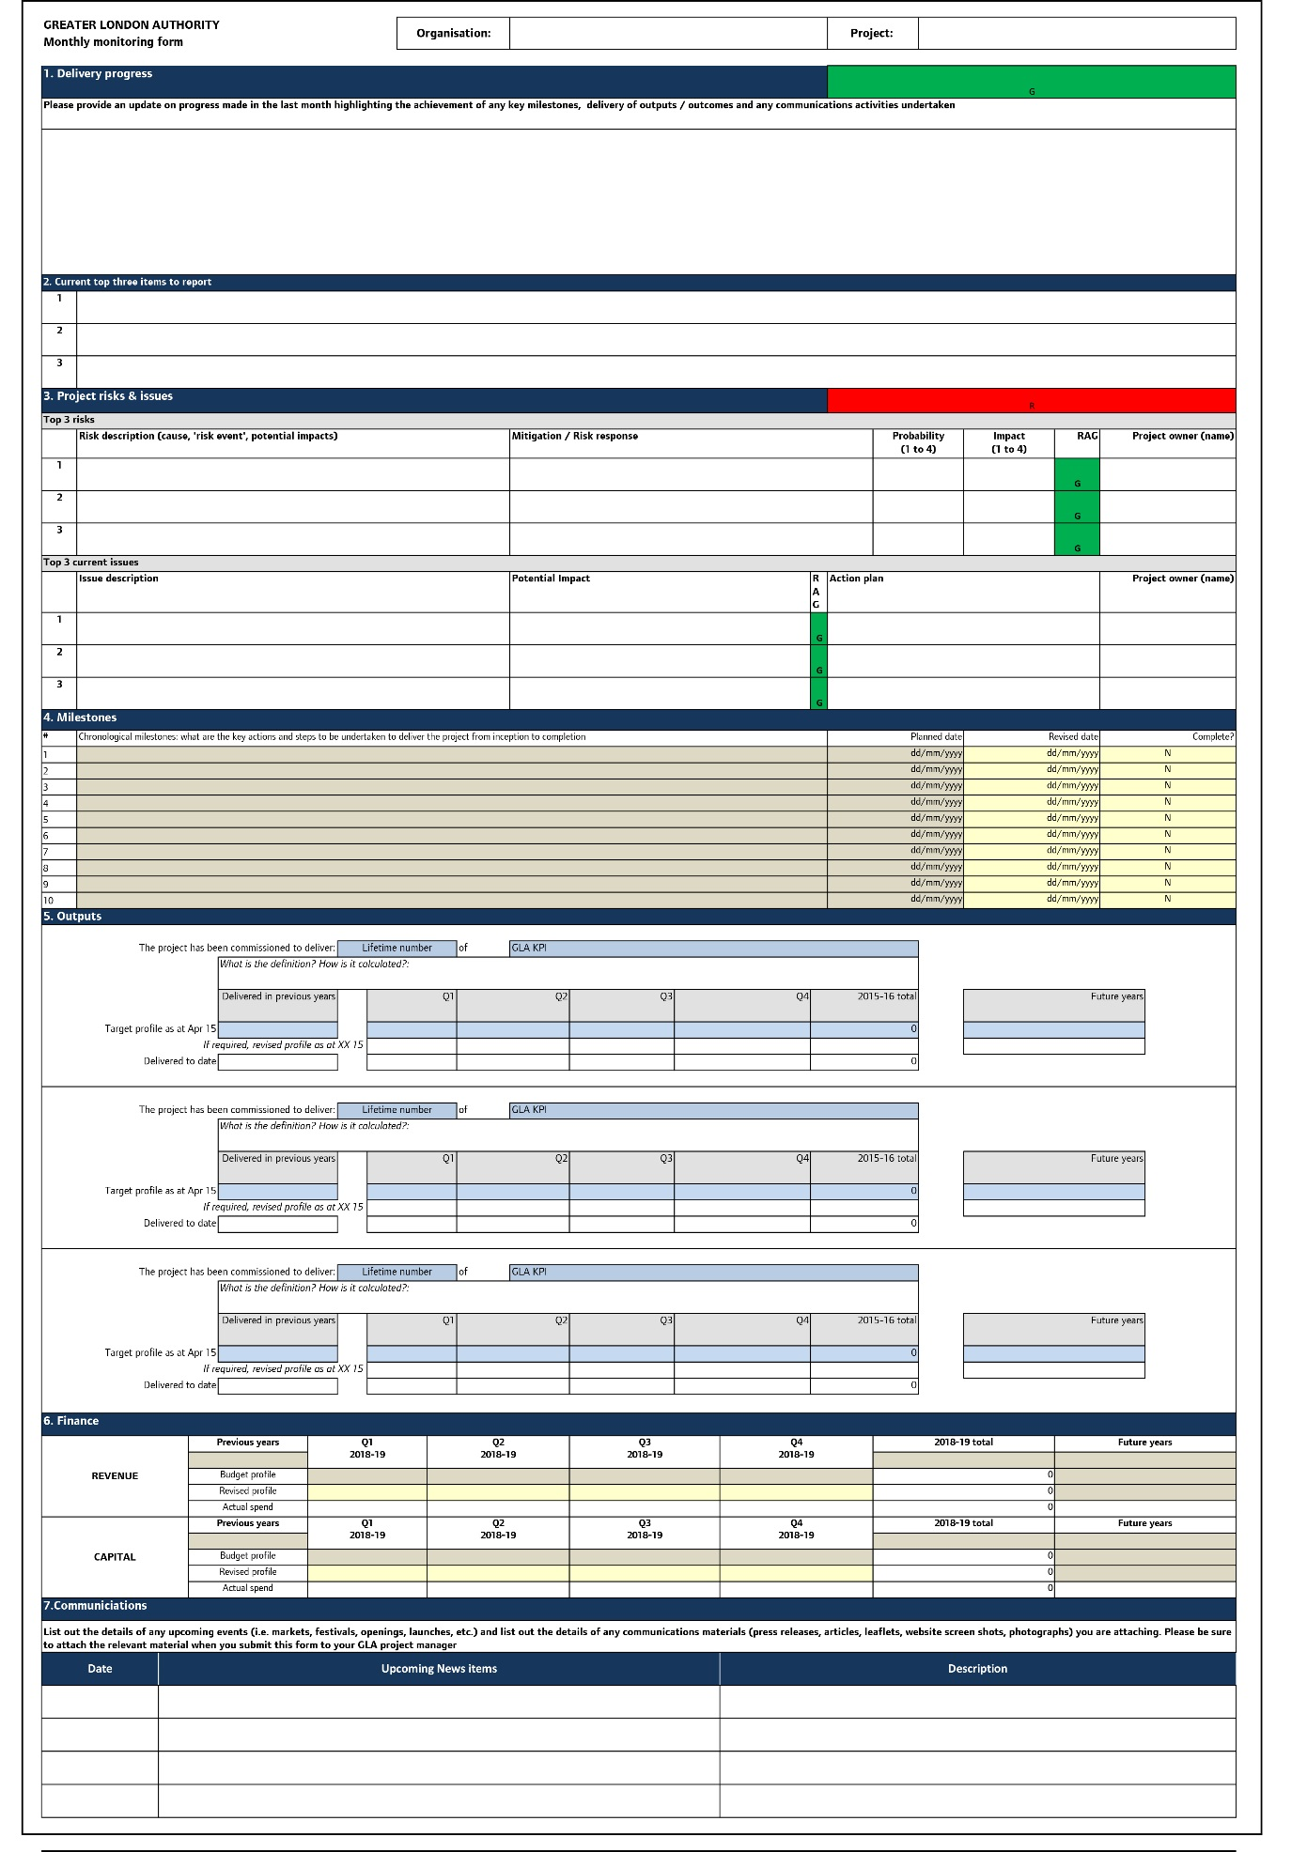

Sample - to be provided in spreadsheet at a later date

**b) Quarterly Claim Form**

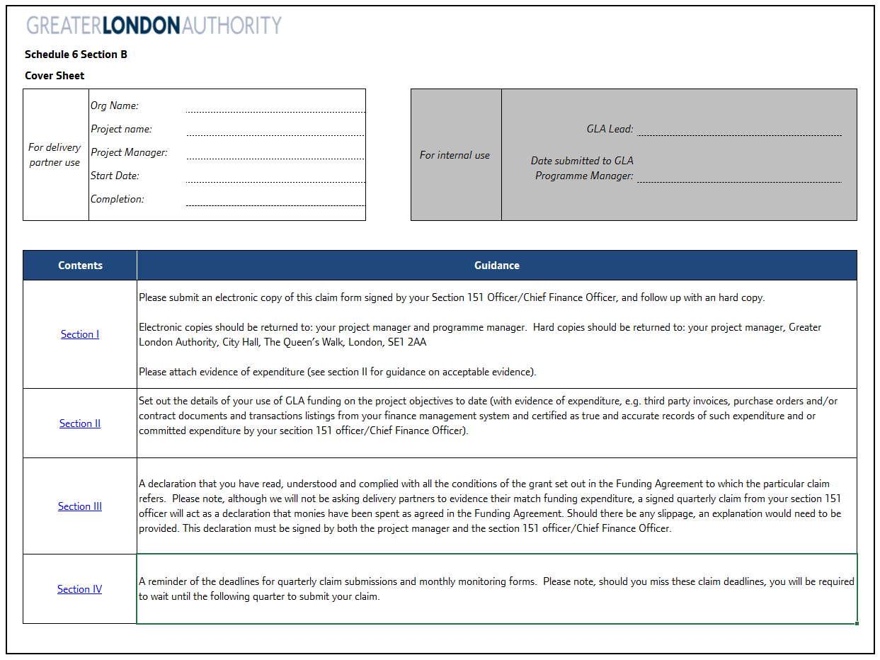

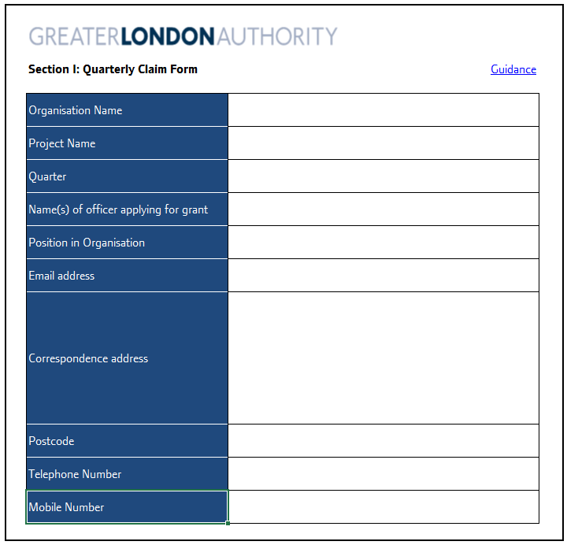

Samples - to be provided in spreadsheet at a later date

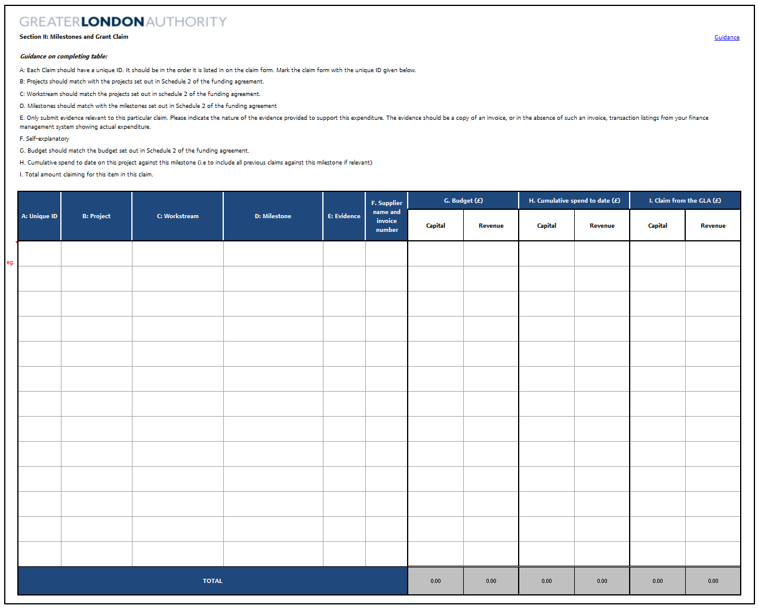

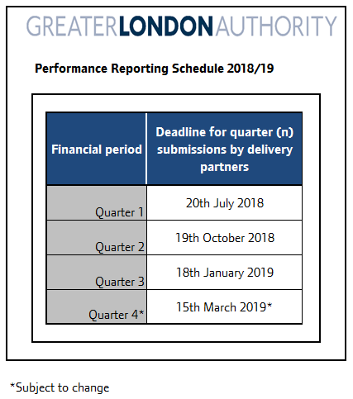

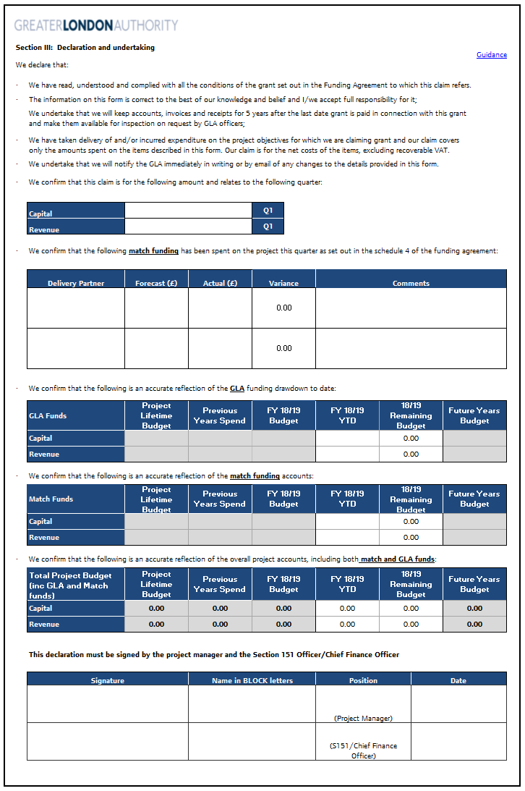

**c. Output Values Return**

**Not applicable**

**Schedule 6**

**Evaluation**

**Evaluation Strategy**

|  |  |
| --- | --- |
| Stage | Description of approach |
| Overview of project context and rationale: the socio-economic  conditions your project is responding to, the local strategic context,  and the beneficiaries that you project is targeting | To complete, please refer to schedule 1 |
| Project objectives: a clear set of objectives which are S.M.A.R.T:  specific, measurable, achievable, relevant and time-specific | To complete, please refer to schedule 1 |
| Project logic chain: your completed project logic chain, setting the  foundations for your evaluation. preparation for delivery to development milestone | To insert, please refer to the Good Growth Fund Evaluation and Impact Handbook for a template |
| Approach to data collection: a summary of how you will collect data  to measure performance against each of the output and outcome  measures, and to understand wider qualitative and strategic aspects  of project performance | To complete |
| Resources and practicalities: a summary of the resources you will  use to collect evidence, focusing on the need for robust and timely  reporting | To complete |
| Future tracking: consideration of how you might track the impact  and legacy in the longer term, once Good Growth Fund delivery  has finished. | To complete |

**Self Evaluation Template**

*To be completed after project completion*

**Section 1: Project Information**

Note: this section is required for submission to the GLA, but may be excluded in versions of the evaluation for publication / sharing with your local partners.

|  |  |
| --- | --- |
| Project Summary: please insert short description of your project | |
| Place and Borough |  |
| Lead Delivery Organisation |  |
| GLA Project Manager |  |
| Self-evaluation lead |  |
| Total GLA funding for project |  |
| Total lifetime cost of project |  |
| Other public/private investment |  |
| Actual Project start date |  |
| Actual Project end date |  |
| Evaluation methodology: please include a short summary of the approach that you have taken to completing the self-evaluation, including the groups and individuals you have consulted with, and the primary research you have undertaken. | |

**Section 2: Stand-out Messages**

A one page summary of your project and key achievements and/or lessons learned. This might include:

* A quick introduction to the project and what’s been delivered
* A summary of impacts achieved to date
* An overview of wider achievements and lessons learned
* Project legacy.

**Section 3: Project Context and Objectives and Design**

This section will provide an overview of the context of the project and summarise how the project was designed to respond to this. This section effectively summarises the information and set out within your bid for funding, and within your grant agreement. It provides a basis against which to test the performance of project delivery.

Please complete the assessment under the following headings:

**3.1: Project background:** a summary of the local socio-economic and strategic context that you project was responding too.

**3.2 Project rationale:** a summary of how your project was designed to respond to this context, and the rationale for public sector intervention (i.e. the need for Good Growth Funding).

**3.3 Project aims and objectives:** an outline of the specific objectives identified by your project at outset.

**3.4 Project design and delivery activities:** please provide a short overview of the project delivery activities agreed at outset.

**3.5 Funding and delivery mechanisms:** please provide an overview of the GLA and match funding agreement for your project (as agreed at outset), and the delivery mechanisms that you were expecting to in place to deliver the project.

**3.6 Project targets:** please set out here the specific output and outcome targets that have been agreed with the GLA, along with any wider measures that you will be assessing your project performance against.

**3.7 Project logic chain:** *please insert your project logic chain which in effect summarises the above information.*

**Section 4: Project delivery**

This section will provide a review of the delivery process after grant agreement stage, including activities delivered, performance in terms of delivery timescales, funding, and outputs (deliverables):

**Section 4.1:** Overview of Project Design Process: a summary of how the project design process, including commentary on stakeholder and community engagement

**Section 4.2:** Activities Delivered: this section should provide an overview of the activities which have been delivered. It should include:

A table summarised the different strands of delivery activity, and a summary of delivery progress

Commentary on each of the strands of delivery activity, outlining what has been delivered and outlining any way in which this evolved from original plans. Photos / plans may help to illustrate this.

Commentary on any strands of delivery not delivered, outlining the reasons for this and how funding was reallocated

**Section 4.3:** Delivery Timescales. A summary of delivery timescales, reflecting on how the project progressed versus the timescales planned at outset, and any reasons for delays.

**Section 4.4:** Funding Performance. A summary of how the project has performed financially. Please include a table which compares actual spend to budgeted spend for each funding source. Please include commentary on any reasons for variance.

**Section 4.5:** Delivery Mechanics. A summary of the mechanisms underpinning delivery. This should consider:

A summary of external support procured (to support design, construction, and delivery), and approach taken to procurement

A summary of project management mechanisms

A summary of any project governance mechanisms put in place (eg project boards or steering groups).

**Section 4.6:** Summary of delivery performance: drawing on the above consideration, a brief summary of delivery performance. As part of this, please include a table outlining how the project has performed against the output targets agreed with the GLA at inception (note: this should focus on output targets only; outcome targets are considered in the next section). The table should include the output target, the agreed definition, the achieved figure (the timing of this figure should be recorded), and commentary which explains variance.

**Section 5: Project impacts:**

This section will focus on the impacts of the project to date.

**Section 5.1:** A review of economic, social and environmental impacts achieved to date.

The structure of this section will need to be developed to reflect the specific characteristics of the project and should explore the impact of your project on the places, communities, people, and businesses it has sought to support. Example impact themes include (but are not limited to): impact on town centre vitality; impact on skills and employment outcomes; impact on business / enterprise performance; impact on community inclusion and vitality.

The analysis is likely to need to draw upon bespoke research on or with the project beneficiaries: this might comprise surveys, focus groups, consultations, or observational research.

Analysis should draw on both quantitative and qualitative insights. Case studies of beneficiaries can be used to supplement quantitative analysis, and are helpful in telling the story of your project.

**Section 5.2:** A review of strategic and financial impacts achieved to date:

Please provide an overview of the strategic impacts of your project. This might include improvements in partnership working, strong leadership shown by partner organisations in working towards shared objectives, improving efficiency by testing new ideas / approaches, or putting in place new systems /structures, or levering in in new funding / resource

If there are any financial impacts of your project (e.g. generation of new business rates, council tax, or improved financial resilience of delivery organisations), please summarise these here. This section can be excluded if not.

**Section 5.3:** Future Impact. A short section exploring how the impacts achieved might be expected to evolve over the coming years (acknowledging that it mind it may take time for certain impacts to emerge).

**Section 5.4:** Summary of impacts to date performance: drawing on the above consideration, a brief summary of impact achieved to date. As part of this, please include a table outlining how the project has performed against the outcome targets agreed with the GLA at inception. The table should include the outcome target, the agreed definition, the achieved figure (the timing of this figure should be recorded), and commentary which explains variance.

**Section 6: Project achievements and lessons:**

Building on the assessment of delivery performance and impacts achieved, this section should provide an overview of overall achievements and lessons learnt. Please complete the assessment under the following headings:

**6.1: Project achievements:** building on the preceding section, identify the areas of greatest achievement for the project. These might relate to any aspect of delivery (from stakeholder engagement, to impacts achieved).

**6.2: Barriers to achievement:** please identify any challenges experienced which acted as barriers to achievement. This might include practical issues (such as problems during construction, to strategic issues (such as challenges securing agreement on designs).

**6.3: Lessons to take forward:** please identify the main lessons that you will take forward in delivering future projects of this nature.

**Section 7: Project legacy and forward plan**

Please provide a summary of the legacy of the project and next steps. Please complete the assessment under the following headings:

**7.1: Project Legacy:** a overview of the legacy of the project. This might include ongoing / complementary delivery activities, the physical / operational legacy of the project, and planned next steps to embed and build on the legacy

**7.2: Challenges and Opportunities:** a summary of remaining challenges or emerging opportunities. These might relate to the delivery / bedding in / long term management of the project, or the surrounding socio-economic context

**7.3: Recommendations:** drawing on the research undertaken, a summary of recommendations to inform ongoing project delivery, or future areas for action / intervention.

**Section 8: Conclusions**

To conclude, please provide short assessment of the extent to which project objectives have been achieved to date, with specific reference to each of the objectives listed in section 3. This should acknowledge where there is further / ongoing work needed to help achieve objectives.

**Schedule 7**

**Name of programme: Good Growth Fund**

**Name of applicant organisation: [ ]**

|  |  |  |  |  |  |  |  |  |  |  |  |  |  |  |  |  |
| --- | --- | --- | --- | --- | --- | --- | --- | --- | --- | --- | --- | --- | --- | --- | --- | --- |
|  | **Total project value (GLA + Match)** | | **Total GLA funding** | | **GLA capital funding** | **GLA revenue funding** | | **Total Match** | | **Recipient Match** | **Non Recipient Match** | | **Recipient Match**  **capital** | **Recipient Match**  **revenue** | **Non Recipient match capital** | **Non Recipient match revenue** |
| **2017-18** |  | |  | |  |  | |  | |  |  | |  |  |  |  |
| **2018-19** |  | |  | |  |  | |  | |  |  | |  |  |  |  |
| **2019-20** |  | |  | |  |  | |  | |  |  | |  |  |  |  |
| **2020-21** |  | |  | |  |  | |  | |  |  | |  |  |  |  |
| I hereby certify that: | | | |  | |  |  | |
|  | |  | |  | |  |  | |
| 1. the organisation named above is eligible to provide public match funding | | | | | |  |  | | | | |
|  | |  | |  | |  |  | | | | |
| 2. the match funding provided does not contain any funds which have been provided by the GLA group | | | | | |  |  | | | | |
|  | |  | |  | |  |  | |
| Signed: | |  | |  | |  |  | |
| Name: | |  | |  | |  |  | |
| Date: | |  | |  | |  |  | |

**Schedule 8**

**Certificate of Output Delivery**

**Not applicable**

**Schedule 9**

**Programme/Project Output Definitions & Evidence Requirements**

**Not applicable**

**Schedule 10**

**Performance reporting**

The Recipient shall unless otherwise agreed in advance by the Authority in writing submit updates on performance to the Authority in the forms set out at :

* + - * Part a of Schedule 5 on a monthly basis; and
      * Part b of this Schedule 5 on a Quarterly basis.

Without prejudice and in addition to the foregoing the Recipient shall also provide the GLA and/or the IMS with:

* + - * such information as is requested and in such form as notified by the GLA and/or the IMS at regular intervals as set by GLA Officers; and
      * notice of, access and invitations to Project sites, Project meetings and board meetings of the Recipient (as an observer at board meetings of the Recipient) and all documentation relating to such Project meetings including (without limitation) agendas for the same at least five working days in advance.

1. <http://ec.europa.eu/competition/state_aid/legislation/de_minimis_regulation_en.pdf>