Lighthouse Service Description

- Introduction
Children or young people (CYP) who have experienced sexual abuse have to relive their experience after disclosure, and risk being re-traumatised. Often agencies work in isolation, meaning children and families can feel alone, left to navigate the health, police and courts system themselves.
The Lighthouse is a place where we put the child at the centre, to make sure they have a safe place to recover at their own pace and rebuild their lives.
All medical, advocacy, social care and therapeutic support will be delivered from one building. The aim is to ensure that all care and support is co-ordinated as we want children, young people and their families to receive the justice, support and therapy they need in a timely manner meaning they can move forward towards recovering from the abuse.
The Lighthouse is also a source of expert advice around child sexual abuse and exploitation. It will be the place where universal services and front-line professionals can call for advice or make referrals.
- Partners
University College London Hospitals NHS Foundation Trust (UCLH) is the lead provider, the other key partners are the National Society for the Prevention of Cruelty to Children (NSPCC) and Tavistock & Portman NHS Foundation Trust (TPFT). The Partnership will also have a sub-contract with Solace Women’s Aid to deliver some of the advocacy support.

Additionally, The Brandon Centre (sexual health service) and Respond (supporting children and young people with learning difficulties that experience CSA/CSE), will provide training, advice and supervision as needed.

Key Principles
The Lighthouse will support improved criminal justice, emotional and mental health outcomes for this cohort of abused children.
The key principles will be:
- Focussing on the recovery of the child, whether or not there is an ongoing criminal justice process
- Jointly planning with the child or young person the support they receive with their lead professional, and ongoing co-design of the service model
- Holistic assessment with space for CYP to share broader concerns, including school, bullying or housing
- Balancing confidentiality with the need to share safeguarding information
- Accessing to mental health support easily and early, meeting the advocate and therapist at the initial medical assessment
- Using a trauma-informed approach to therapeutic support
- Listening to the child and non-abusing parents
- Offering support to non-abusing parents, carers, siblings and family
- Following CPS guidelines for pre-trial therapy, ensuring that there is no impact on future criminal justice processes
- Allowing CYP to access services on their own terms and giving them time to work at their own pace
- Providing a service that meets the child or young person in the right place for them, including outreach
- Creating trusted relationships between the child and the team
- Building a strong and well supported team with time for reflection, supervision and mentoring
- Working in partnership across agencies with a commitment to collaborative working and flexibility across professional remits
- Providing expertise, advice and training for other professionals

- 4. Service Model

- 4.1. Partnership
- Diagram 1a. shows which element of service delivery the separate organisations are responsible for.

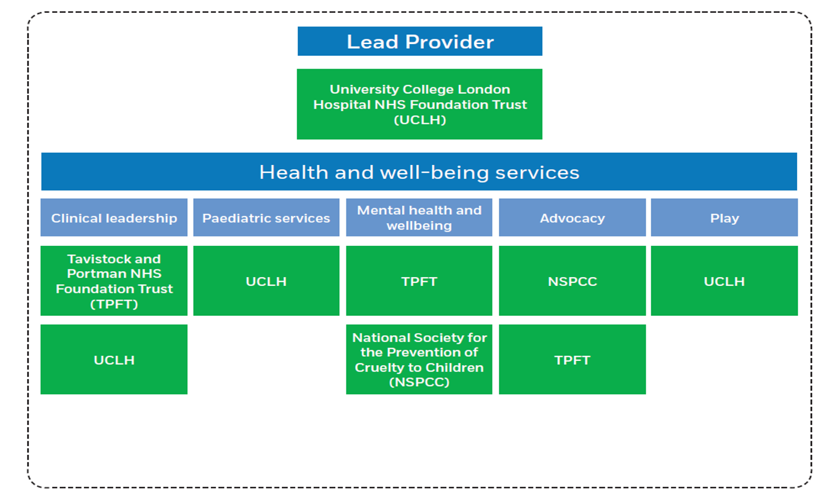
Solace
Diagram 1a

4.2 Team
Diagram 1b shows the professionals working within The Lighthouse. It includes paediatricians, paediatric / sexual health nurses, advocates, therapists, clinical psychologists, CAMHS practitioners and children’s services practitioners, as well as social care, police liaison officers and how they link to our closest external partners.

4.3 Roles and responsibilities:
Management
The UCLH Lighthouse Service Manager will head the service overall, working closely with the paediatric and mental health leads (who jointly take the clinical lead for Child House). The manager and clinical leads will report respectively to the UCLH Paediatrics and Adolescents Divisional Manager and Divisional Clinical Director.

Medical team:
At the initial appointment at Child House, core team members will be available (paediatrician, nurse, play specialist, mental health and advocacy), as well as the child’s social worker. The initial assessment will include a holistic medical, emotional and sexual health assessment, risk and safety planning, and assessment of family strengths and difficulties. Our standard operating procedure to maintain chain of evidence will be adapted and audited. Samples will be transported by a member of the Lighthouse team to UCLH’s laboratory. Follow up and safeguarding support will be provided by the paediatrician or nurse; depending on the case complexity and to allow for leave.

Mental health and wellbeing:
Based on experience from the CSA hubs, we predict after the core assessment and risk planning that 50% of CYP will require either LTFI or P&R support, 30% will require a CAMHS intervention, 10% will prefer local support e.g. school, and 10% will not want any support at that time. As shown in Section 5, the pathway will allow open access for any CYP that have attended Lighthouse to self-refer back into service during the pilot period.
Where appropriate, an ABE-trained clinical psychologist or children’s services practitioner will lead the ABE interview with oversight from the investigating officer. Even if the ABE interview is led by the investigating officer or local ABE-trained social worker, Lighthouse will be used as the venue.
Dr Robert Senior, mental health and wellbeing lead will be responsible for:
- CAMHS therapeutic team – TPFT
- LTFI team (sexual abuse recovery programme) – NSPCC
- Protect & Respect (P&R) team (CSE support programme) – NSPCC
- -Advocacy team – NSPCC and Solace
Each team will have a senior practitioner responsible for case allocation, training, supervision and peer review.

4.4 Skills and competencies:
- CAMHS clinicians will have experience of delivering trauma-informed services, such as trauma-focused CBT and screening for PTSD using the Trauma Symptom Checklist for Children (TSCC). A mixed team of part-time practitioners will allow clinicians to be drawn from the current CSA hubs and varied CAMHS speciality teams bringing a wealth of skills and backgrounds, such as family therapy, clinical social work, child and adolescent psychology and psychotherapy.
- NSPCC practitioners will be children services practitioners by background and have completed NSPCC training, including LTFI and P&R procedures, safety planning, assessment with the TSCC and working therapeutically with children following sexual abuse.
- Our paediatricians are already experienced in CSA forensic and holistic medical examinations with video-colposcopy, undertake at least 20 medicals a year, participate in peer review and bring previous experience of multi-disciplinary assessment in the CSA hub.
- Advocates will be recruited from a background in victim support, directly supporting CYP and (ideally) with a child protection background.
- The nurse will bring experience of working with CYP and in sexual health.
- The play specialist will have experience preparing children for clinical procedure
4.5 Evidence based practice
The service will utilise evidenced-based interventions, such as Letting The Future In (LTFI) and trauma-focused CBT, as recommended in the NICE Child Abuse and Neglect Guideline (NG76).

5. Care Pathway
5.1 Referrals
Referrals into The Lighthouse will primarily come via the 5 MASHs and Police. However, dependent upon circumstances could come via schools, GPs and other professionals from universal or targeted services.
Those CYP which will require collection of forensic evidence will attend the Havens. However, there will be ease of access to Lighthouse services to support anxious children and families in the early days after disclosure.
Families and children can self-refer. This will be by telephone, online via the website, or via a text number which will be widely available. They will always speak to an experienced advocate who will supportively guide them through the next steps.
5.2 Short term work
Diagram 1c shows how the team will work together to provide care in the first few days of the child or young person being referred into the Lighthouse. During this time the child or young person may have:
- A holistic medical assessment (including sexual health)
- ABE interviews
- Advocacy support
- Early emotional support
- Long-term support

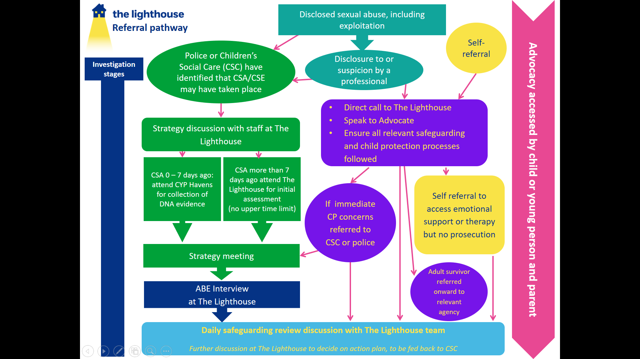

5.2 Medium / Long-term
Diagram 1d. Represents how the team will work together to support the child, young person and their family over the following days, weeks and months. The team will respond to the needs of the family, where the work will be co-ordinated by the Lead Professional to ensure the service is seamless for the family.

.

6. Case Management
For CYP where there is an immediate need of a co-ordinated approach following disclosure, a conference call will be organised via the police liaison officer. This should include police officers, relevant children social care professionals and a clinician from The Lighthouse or CYP Haven. A decision will be made as to whether the child or young person should be examined at Lighthouse or

CYP Havens. Anyone at risk of suicide or severe self-harm will have a mental health assessment in the Emergency Department.
Front line practitioners who are unsure if the issue they are dealing with should be reported, or only have suspicions, they may call Child House. They will speak to an advocate, social work liaison officer and / or police liaison officer who have expertise in child protection and are able to advise them, ensuring all procedures have been followed. Any self-referrals into Lighthouse will be managed via protocols (similar to CYP Havens) ensuring all safeguarding and safety elements are taken into account.
If a young person decides they do not want the police to investigate, the police liaison officer or advocate will discuss the potential options, including storing evidence for later use. In cases of statutory rape (where the child is under 13), it will always be forwarded onto the police.
Most ABE interviews will take place at Lighthouse and led by psychologists, police or a local social worker (if they have the best relationship with the child and are suitably trained).
Daily allocation meetings will consider all safeguarding risks for CYP seen in the previous 24 hours, ensuring appropriate action is taken. At this meeting, the needs of the CYP will be discussed, with the advocate taking responsibility to ensure these needs are taken into account and remedial actions taken. For example, if a CYP has a learning difficulty or if English is not their first language, a plan bespoke to them will be developed for the next steps. We will seek advice and support from Respond about how to best support CYP with learning difficulties. The advocate will represent the child’s wishes at the meeting and act as a liaison with the family. An initial support package for non-offending family members will be discussed and put in place at this point.
There will be a weekly case meeting and care planning discussions for all involved in the care of CYP, with staff bringing cases for discussion of next steps.
A six week assessment and early help offer will be in line with NICE Guidance 76 and evidenced to reduce progressions to PTSD by 65%. This will be undertaken by both LTFI and CAHMS workers (depending on the joint decision by the team) and include a baseline assessment, such as the Trauma Symptom Checklist for Children.
CYP will be involved in choosing the right support for them, such as the CSA therapeutic work from LTFI, the P&R CSE programme or, for more complex cases, from the CAMHS workers in the team. Others may prefer to be supported by local services, such as youth services or a school counsellor, in which case the Lighthouse team will provide supervision using the “team around the worker” model. We will hand over to a primary care team at discharge with open access should issues arise in the future.
Ongoing review of the pathway will take place and be part of whole team development days, including number and type of referrals, feedback from CYP and family / carers, and staff feedback. This will be undertaken on a quarterly basis and will feed up through the delivery board. Senior management will monitor a set of core KPIs as part of this feedback loop to ensure continuous improvement.

5.3 Daily/weekly schedule:
As there is no immediate need to gather forensic evidence, appointments are less time critical than at the Havens. All attendances at The Lighthouse will be via booked appointments.

Weekday mornings:
- Daily allocation meeting to discuss referrals in and allocate cases and decide on next steps
- Full team available for booked initial assessments

Weekday afternoons:
- Weekly team case management meetings
- Peer review and supervision
- Research and audit
- Service development and engagement with users
- Professional liaison and external meetings
- Training for other professionals
- CPD

Weekdays after school, early evening and Saturdays:
- Follow up appointments with medical team
- Therapeutic programmes (individual and group work)
- Parent and carer support (individual and group work)

Sundays:
- Emotional support and therapy if required (demand will be monitored, user engagement will shape the service offer)

ABEs can be booked during opening hours with ABE-trained practitioners (Lighthouse psychologist, officer in the case or social worker) and at times appropriate to the age of child and investigative urgency

7. Lighthouse building and outreach:
The Lighthouse building is a child-friendly space that meets the varying needs of CYP and families / safe carers. Children and young people informed the look and feel of the building.
It includes:
- A welcoming arrival area, easy access to refreshments
- Physical separation between medical and ABE interview areas from areas where CYP will receive ongoing emotional support and therapy.
- Systems in place to ensure secure storage of photo / video documentation DVDs for robust chain of evidence.
- A focus on safety and security for CYP with trained and friendly staff around at all times.

- Staying Child Centred
However, not all CYP will want to come back to The Lighthouse for ongoing support and therapy. We will ensure flexibility to allow advocates and therapists to support children, young people and their family’s closer to home, such as at school, children’s centres or public spaces where the individual feels comfortable, and at times that are more convenient for them, such as evenings or weekends. We will operate flexibly within the building to provide group work, creative spaces and whole family sessions.

Lighthouse Strategic and Operational Management
There will be a tripartite management team within Lighthouse comprising of the Lighthouse Service Manager and the clinical leads for paediatrics and mental health and wellbeing. The Lighthouse Service Manager will be employed be UCLH full time, and sufficiently senior to support both the establishment of the new service and model, and the development of strategic relationships across the wider system to embed the Lighthouse model.
Key strategic responsibilities for these roles include:
- Strategic Lighthouse Service Manager - Influencing and creating partnerships at senior levels with all key stakeholders, including the CPS, police and Judiciary. Ensuring the partners and sub-contractors are able to deliver within the governance and contractual framework.
- Clinical leads - Providing visible clinical leadership to champion the Lighthouse model, raise national awareness, and sharing compelling stories to influence colleagues in the criminal justice system and beyond.
- weekly senior team meetings (Service Manager and joint clinical leads)
- monthly operational meetings for core Lighthouse team
- monthly Delivery Board with Lighthouse team and senior leaders from local partners, including police, social care and CPS
- challenge and recommendations from the Shadow Board, as well as input from adult survivors and non-offending families
- assurance provided to commissioners and senior partners at Programme Board
- UCLH assurance provided, via divisional meeting and Safeguarding Committee, to Senior Director Team and ultimately the Board.
The Service Manager will have operational responsibility for:
- Day-to-day management of the core team, including admin and senior practitioners
- Liaison and oversight of social care and police liaison officers, as well as visiting social workers, investigating officers and CPS lawyers
- Performance reporting and quality assurance
- Budget management in association with the UCLH finance team
- Partnership working and sub-contracting with the organisations in partnership, in association with UCLH contracting team

The clinical leads will have operational responsibility for:
- Ensuring the supervision model is in place for all staff within and outside Child House
- Day-to-day management of the workforce to cover opening hours with appropriate skill mix and competencies
- Ensuring a competent workforce engaging in professional development, succession planning and research
- Clinical governance and safety of services
- Health and wellbeing of staff

We will grow the existing operational and strategic alliances with police, social care and third sector partners in North London to include partners such as CPS and the Judiciary.
The alliance will be created at multiple levels including:
- Trust and relationships between frontline practitioners through shared supervision, case meetings and open days
- Open and honest partnership working between partner organisations at the Operational Group, collaboratively resolving pathway issues, creating shared understanding of risk, sharing themes and learning
- Shared strategic vision and accountability at Delivery Board with senior leaders, including directors/ CEOs and senior local leaders from police, local authority and criminal justice system.

Governance
Each partner will use the Lighthouse shared record for assessments, care planning and reports, with clinical detail on their own patient record system.
We will build on existing local partnership governance arrangements in Camden to create the Delivery Board, chaired by UCLH, bringing together partners in the pathway. These include police (Central North Basic Command Unit, Child Abuse and Sexual Offences (CASO) and CSE team leads), CPS and local children’s social services. The Delivery Board will report to the UCLH and escalate any issues with external agencies and to Child House Programme Board.
Case discussions will take place at daily and weekly planning meetings. Advocates will ensure the child and family support is in line with their wishes and keep them up to date with progress via the social care and police liaison officers, acting as a single point of information.
The Operational Management Group will discuss risk, incidents, quality standards, training, competency, audit and research, with an extended quarterly meeting to review themes. The group will provide quarterly assurance reporting to the Delivery Board.
The Delivery Board will ensure agreed procedures and protocols meet London-wide safeguarding procedures, local and national guidelines, and procedures used in CYP Havens. There will be regular audit to ensure policies and procedures are adhered to, with regular random case selection. Overall clinical accountability for individual cases will be held by UCLH, with local partners providing quality assurance through sub-contract review meetings. Decision making framework: - weekly senior team meetings - monthly operational meetings - monthly Delivery Board meetings with the team and local partners - challenge and recommendations from the Shadow Board of young people - monthly assurance at Programme Board Operational line management.

The Service Manager and clinical leads will meet weekly to ensure disciplines work together focused on the child’s needs. The clinical leads will manage the clinicians and senior practitioners will lead each team. The Service Manager will provide day-to-day line management for the admin team, social care and police liaison officers.
A child’s allocated local social worker will attend The Lighthouse for care planning as required. They will attend the first assessment to be fully aware of the allegation, the work needed for each child and family, and consider holistic issues (such as housing, foster care and education). The social care and police liaison officers will attend all five MASH and MACE to support appropriate referrals to Child House. A Lighthouse team member will attend child protection conferences. Strategy and professional meetings can be hosted at Lighthouse when in the best interest of the child. We will invite local safeguarding practitioners to open days, and ensure marketing and communication is undertaken throughout the mobilisation phase.

