Child House Partnership Oversight and Sustainability Board
(CH POSB)
Terms of Reference
- Context
MOPAC and NHS England (London) has lead the development of a pilot ‘Child House’ in London, with majority funding from the Home Office and match funding from MOPAC, NHS England (London) and the Department for Education. Partner agencies have come together to establish medical, investigative and therapeutic services ‘under one roof’, alongside support for child victims to progress more rapidly through the criminal justice and court process. The lead provider for the service is University College London Hospital NHS Foundation Trust (UCLH) working alongside their sub contracted partners Tavistock and Portman NHS Foundation Trust and NSPCC.
- Purpose
The CH POSB will maintain oversight of the service, evaluation and the strategic partnership arrangements for the duration of the two-year pilot. The CH POSB will also ensure that a clear sustainability plan is in place for the service, as well as provide assurance to partners that the delivery of the Child House remains on track.
- Key functions
The CH POSB will:
- Make key decisions in relation to:
  - The service within the Child House;
  - The evaluation of the pilot; and
  - Sustainability
- Be an escalation point for partnership issues and also escalate issues further if appropriate.
- Ensure delivery of the pilot within budget.
- Regularly review risks and provide assistance and guidance in reducing these.
- Ensure that there is a robust approach to the evaluation of the pilot which addresses the key outcomes including improved awareness of CSA and experiences of health and CJS services, and increased likelihood of charges and convictions.
- Ensure a considered sustainability plan is in place.
- Ensure an effective communication (internal and external) and service user engagement strategy.
- Ensure that there is effective key stakeholder engagement, especially but not only with children and young people, and that this can be evidenced in service provision.
- Ensure links with wider work within London related to violence against women and girls, child and adolescent mental health services, children’s social services and the criminal justice system.
- Ensure the sharing of good practice and learning from the UK and internationally.
- Liaise with cross governmental advisory groups to keep them informed of progress and ensure the Child House pilot is developed in line with national policy direction.
- Membership
Members of the Board will have responsibility for leadership within their own organisation and aligning strategic plans and operational priorities. They will have the authority to make decisions on behalf of their organisation at CH POSB meetings.
The membership of the Board includes representatives of:
ORGANISATION | NAME
Core Members:
MOPAC | Rebecca Lawrence (Chair), Chief Executive Officer  Gareth Linington, Programme Manager  Dean Nevill, Programme Officer  Lynne Conroy, Principal Research Officer
NHS England (London) | Matthew Bazeley, Director of Public Health, Health in the Justice System and Armed Forces Commissioning  Chloe Collins, Senior Commissioning Manager – Health in the Justice System
Lead provider | Felicity Hunter (UCLH),  Emma Harewood (UCLH), Development and Service Manager  Jon Brown (NSPCC), Head of Development and Impact  Rob Senior (Tavistock and Portman NHS Foundation), Consultant Psychiatrist
CPS | Sara Carnegie, national CPS  Rachel Butterfill, Strategic Policy Advisor
HMCTS | Michelle Filby, Head of Crime  Jan Martin-Essoui, Business Change Manager
Home Office Representative | TBC, Policy Lead for Victims of Sexual Violence and Child Sexual Abuse  Teema Nicholls, Policy Adviser on Victims of Child Sexual Abuse  Darren Geater, Law Enforcement Transformation Unit
MPS Representative | Commander Richard Smith, Head of Profession for Safeguarding
CCG Representative | Dionne Usherwood, Head of Children’s Integrated Commissioning (Camden)
Local Authority Children’s Social Services Representative | Anne Turner, Director of Children’s Services (Camden)

Other organisations may be invited to attend Board members as required, by invitation.
- Governance framework
The Board is one of four pillars within the overall governance framework. This includes contract management; operational management across the provider partnership; and victim/survivor/patient feedback and participation. The relationship between the pillars is shown in the diagram overleaf.

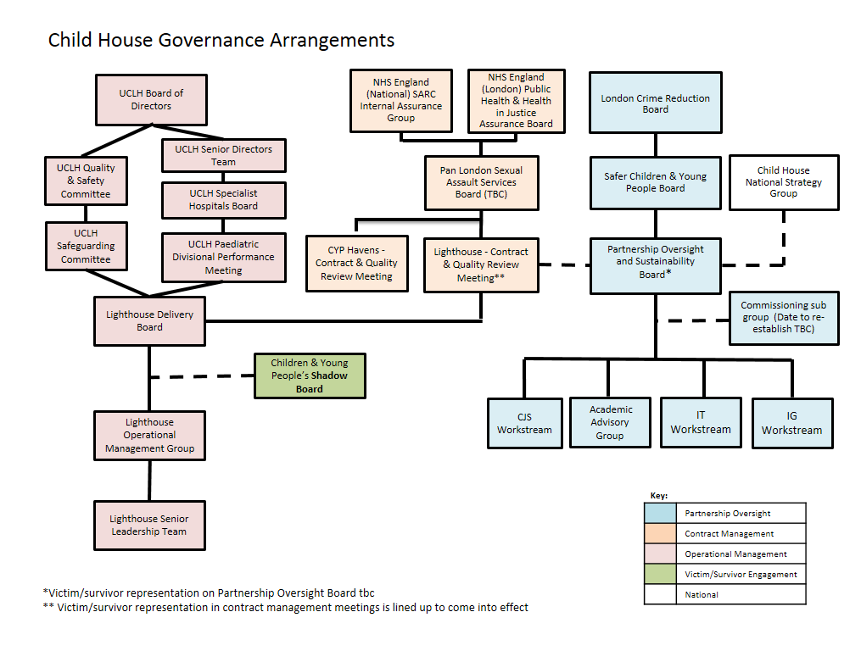
5.2 Commissioning Group
The Commissioning Group will be formed of NHS England and MOPAC commissioners along with representatives of local CCG and local authority commissioners in the STP area where the pilot is to be based. The Commissioning Group will:
- Act as a confidential forum for the commissioners of the pilot
- Allow commissioners to develop commissioning proposals for recommendation to the board
- To ensure the decisions of the board are taken in such a way that is compatible with the internal governance and decision making of all partners.
- To ensure that the pilot delivers best value for all Londoners
- To ensure that the pilot is developed in a way that can be sustainably commissioned in the long term.
5.3 Work streams
The Child House Programme has four sub-groups, others may be set up as and when needed:
- CJS – led by CPS
- Academic Advisory Group – led by MOPAC
- IT – led by MOPAC
- IG – led by UCLH

- Meeting Arrangements
6.1 Frequency of meetings
The CH POSB will meet every two months.
6.2 Administration
MOPAC will provide agenda planning and secretariat support.
6.3 Links to wider governance
The Board will agree who will represent them within the wider governance structure, especially that for the London programme for VAWG and cross governmental advisory groups.
6.4 Measuring progress
A standard agenda item will be the review the CH risk register. The Board will agree the approach to evaluation working with other areas of England where appropriate.
Standard CH POSB agenda
Item | Subject | Lead
1 | Welcome, introductions & apologies | Chair
2 | Minutes of the last meeting and matters arising | Chair
3 | Service update | Lead Provider
4 | North Central London update | LA Representative
5 | Evaluation | MOPAC
6 | Sustainability | MOPAC
7 | CJS | CPS
7 | Risk review | MOPAC
8 | AOB and date of next meeting | Chair

